Faculty of Architecture and Engineering

Department of Computer Engineering

M.Sc. Ari Gjerazi

M.Sc. Edlira Cani

SWE202

StudiShare Software Model & Design

March 12th, 2025 – May 27th 2025



**Members:** Halil Bagosi (**Leader**), Ameraldo Bullari, Daniela Brahimi, Dea Hoxha, Dionis Beçi, Jagoda Andrea

**Table of Contents**

1. Executive Summary 3

1.1 Project Overview 3

2. Product/Service Description 3

2.1 Product Context 3

2.2 User Characteristics 4

2.3 Assumptions 4

2.4 Constraints and Dependencies 5

3. Requirements 5

3.1 Functional Requirements 5

3.2 Non-Functional Requirements 8

3.2.1 Product Requirements 8

3.2.2 Usability Requirements 8

3.2.3 Performance Requirements 9

3.2.4 Availability 9

3.2.5 Security 9

3.2.6 Organizational Requirements 9

3.2.7 External Requirements 10

4 User Scenarios/Use Cases 10

5. Diagrams 44

5.1 ER diagram 44

5.2 Use Case Diagram 45

5.3 Activity Diagrams 46

5.4 Class Diagram 75

5.5 State Diagrams 76

5.6 Sequence Diagrams 82

5.7 Collaboration diagrams 111

6. Design patterns 128

6.1 Singleton Pattern 128

6.2 Observer Pattern 128

6.3 Facade Pattern 130

6.4 Factory Method Pattern 131

6.5 Decorator Pattern 132

# Executive Summary

## Project Overview

The goal of StudiShare is to revolutionize the way students learn and collaborate by providing a comprehensive dynamic platform where they can freely exchange educational materials and resources. By facilitating the sharing of materials and textbooks, StudiShare aims to empower students to enhance their learning experience while promoting a culture of collaboration and knowledge sharing. Subject-matter-specialists can also find a new way to revitalize their knowledge on certain fields by helping out students in need. Additionally, by integrating accessibility features such as audio conversion for visually impaired users, StudiShare strives to ensure inclusivity and equal access to educational resources for all learners.

# Product/Service Description

StudiShare’s development is shaped by key factors that ensure it meets the needs of students, educators, and accessibility-focused users.

• **Educational Accessibility & Sharing** – Students need a centralized, user-friendly platform to access and share study materials, driving requirements for structured content organization and intuitive search.

• **Affordability** – High textbook costs necessitate a marketplace for affordable resources, influencing payment integration and pricing models.

• **Technology & Digital Learning** – Online education trends require AI-driven recommendations, cloud storage, and mobile accessibility.

• **Community & Engagement** – Peer-to-peer learning, mentorship, and rating systems encourage participation, shaping requirements for user interaction and feedback.

• **Accessibility & Inclusivity** – Features like text-to-speech enhance usability for visually impaired users, guiding UI/UX and assistive technology integration.

• **Security & Privacy** – Protecting user data and transactions necessitates encryption, secure authentication, and compliance with privacy regulations.

• **Scalability & Performance** – Growing user demand requires efficient cloud infrastructure, optimized search, and database management.

• **Market Differentiation** – StudiShare stands out by combining free and paid resource sharing with mentorship and accessibility, emphasizing usability and innovation.

## Product Context

StudiShare is a self-contained educational platform that facilitates the sharing, buying, and selling of academic resources. However, it interfaces with external systems to enhance its functionality:

• **Payment Gateways** – Integrates with PayPal, credit/debit cards, and digital wallets (Apple Pay, Google Pay) for secure transactions.

• **Cloud Storage Services** – Utilizes cloud-based storage to manage user-uploaded content efficiently.

• **Video Conferencing Tools** – Links to platforms like Zoom, Google Meet, or Microsoft Teams for mentorship sessions.

• **Assistive Technologies** – Supports text-to-speech conversion for visually impaired users.

• **Authentication Systems** – Includes social logins via Google or Apple for a seamless user experience.

## User Characteristics

1. **Students (Primary Users)**

• **Experience:** High school, undergraduate, and graduate students.

• **Technical Expertise:** Basic to moderate (comfortable with mobile apps, web navigation, and online payments).

• **Needs:** Access to study materials, mentorship, and affordable textbooks.

2. **Faculty & Mentors (Secondary Users)**

• **Experience:** Professors, tutors, and subject-matter experts.

• **Technical Expertise:** Moderate to advanced (familiar with digital learning tools and content creation).

• **Needs:** Uploading educational content, mentoring students, and managing subscriptions.

3. **Visually Impaired Users**

• **Experience:** Students with accessibility needs.

• **Technical Expertise:** Varies; relies on assistive technologies.

• **Needs:** Text-to-speech functionality and an accessible UI.

4. **Administrative Staff**

• **Experience:** University or platform administrators managing content and users.

• **Technical Expertise:** Moderate (familiar with user management and platform settings).

• **Needs:** Moderation, system maintenance, and policy enforcement.

## Assumptions

**Internet access** – The platform requires an internet connection for content access and transactions.

• **Basic digital literacy** – Students and mentors are expected to navigate web and mobile applications.

• **Availability of third-party services** – Payment gateways, cloud storage, and video conferencing tools will remain operational.

• **Device compatibility** – Users are assumed to have access to modern smartphones, tablets, or computers.

## Constraints and Dependencies

**Constraints**

• Security & Privacy Regulations – Compliance with data protection laws for secure transactions and content management.

• Accessibility Standards – Adheres to WCAG guidelines for visually impaired users.

• User Verification – Must ensure fair transactions while protecting against fraudulent activity.

• Payment Processing Limitations – Subject to third-party transaction fees and regional availability of payment services.

• Storage Limitations – May impose upload limits based on available cloud storage capacity.

**Dependencies**

• Third-Party Integrations – Requires external payment processors, cloud storage, and video conferencing tools.

• Mentorship Feature Activation – Depends on mentor participation and subscription models.

• Content Quality Control – Relies on a rating/review system to maintain high-quality educational materials.

• Scalability & Performance – Growth depends on cloud infrastructure and efficient database management.

# Requirements

## Functional Requirements

| **Req#** | **Requirement** | **Comments** | **Priority** | **Date Rvwd** | **SME Reviewed / Approved** |
| --- | --- | --- | --- | --- | --- |
| BR_01 | Student shall access educational resources(search, filter, preview, download, purchase history) |  | 1 | 21/03/25 | M.Sc Edlira Cani |
| BR_02 | The system shall facilitate study sessions by enabling mentors to manage lessons, availability, and session durations.( to organize live lessons, set availability, and manage session durations) |  | 1 | 21/03/25 | M.Sc Edlira Cani |
| BR_03 | The system shall enable student work submission and mentor feedback process. |  | 1 | 21/03/25 | M.Sc Edlira Cani |
| BR_04 | Student shall manage study materials.(upload, tag related subject) |  | 2 | 21/03/25 | M.Sc Edlira Cani |
| BR_05 | The system shall have a text-to-speech option for materials and study materials. |  | 2 | 21/03/25 | M.Sc Edlira Cani |
| BR_06 | The system shall allow users to modify their profile. | Users shall be able to change their profile picture, field of study, interest-subjects and username | 2 | 21/03/25 | M.Sc Edlira Cani |
| BR_07 | The system shall rank mentors based on user rating and feedback. |  | 3 | 21/03/25 | M.Sc Edlira Cani |
| BR_08 | The system shall allow users to customize which notifications they receive on their devices. |  | 1 | 21/03/25 | M.Sc Edlira Cani |
| BR_09 | The system should support multiple languages for the user interface and content. |  | 2 | 21/03/25 | M.Sc Edlira Cani |
| BR_10 | The system shall offer students the ability to download materials and lectures for offline access. |  | 1 | 21/03/25 | M.Sc Edlira Cani |
| BR_11 | The system shall allow students to put a price on a material. | Students should be able to sell their materials to other students. | 1 | 21/03/25 | M.Sc Edlira Cani |
| BR_12 | The system shall support sign language educational resources for hearing-impaired users. |  | 2 | 21/03/25 | M.Sc Edlira Cani |
| BR_13 | The system shall allow users to view course syllabus for different subjects. |  | 3 | 21/03/25 | M.Sc Edlira Cani |
| BR_14 | The platform shall allow mentors to conduct live classes. |  | 3 | 21/03/25 | M.Sc Edlira Cani |
| BR_15 | The platform shall implement an algorithm for personalized recommendations based on user preferences and activity. |  | 1 | 21/03/25 | M.Sc Edlira Cani |
| BR_16 | The system shall give users the ability to buy paid materials. | Students will be able to use bank transfer, credit card and online wallets (Apple Pay, Google Pay, Samsung Pay, PayPal) | 2 | 21/03/25 | M.Sc Edlira Cani |
| BR_17 | The platform shall allow mentors to upload recorded lessons. | This enables mentors to provide on-demand learning content for students who miss live sessions or prefer self-paced study. | 2 | 21/03/25 | M.Sc Edlira Cani |
| BR_18 | The system shall support audio-based study materials with accessibility features. | Option to have a transcript of audio materials. | 2 | 21/03/25 | M.Sc Edlira Cani |
| BR_19 | The system shall allow students and mentors to list books for sale or rent. | Listing books with pricing and condition details, messaging between buyers and sellers, and secure transaction tracking. | 2 | 21/03/25 | M.Sc Edlira Cani |
| ~~BR_20~~ | ~~The system shall offer a notification and alert system for key user activities.~~   * Users shall be able to delete their account if they decide they want to do so. | ~~Alerts for mentorship session updates, study material availability, textbook marketplace activity, and important platform announcements.~~ | ~~1~~ | ~~21/03/25~~ | ~~M.Sc Edlira Cani~~ |
| BR_21 | Users shall be able to delete their account if they decide they want to do so. |  | 1 | 21/03/25 | M.Sc Edlira Cani |
| BR_22 | Users shall be able to change/modify their credentials(email, password, birthdate, phone number). |  | 1 | 21/03/25 | M.Sc Edlira Cani |
| BR_23 | The system shall allow users to request help on their schoolwork. | This will work in a forum-style where users can respond to the poster with relative solutions. | 3 | 21/03/25 | M.Sc Edlira Cani |
| BR_24 | The system shall implement screenshot or screen-record blocking for mentor shared materials . |  | 1 | 21/03/25 | M.Sc Edlira Cani |
| BR_25 | The system shall allow students to review, rate and report study materials. |  | 3 | 21/03/25 | M.Sc Edlira Cani |
| BR_26 | The system shall allow students to create custom goals. | System reminds the student with notifications to stay on track | 3 | 21/03/25 | M.Sc Edlira Cani |
| BR_27 | The system shall allow students to bookmark and categorize study materials. |  | 3 | 21/03/25 | M.Sc Edlira Cani |
| BR_28 | The platform shall allow mentors to create quizzes or assignments for students to complete during or after a lesson. |  | 3 | 21/03/25 | M.Sc Edlira Cani |
| BR_29 | The system shall include a feature for students to track their time spent on different study activities and sessions. |  | 2 | 21/03/25 | M.Sc Edlira Cani |
| BR_30 | The system shall enable students to participate in monthly challenges or competitions related to their studies, with rewards for completion (e.g., badges, certificates). |  | 3 | 21/03/25 | M.Sc Edlira Cani |
| BR_31 | The system shall allow students and mentors to communicate via direct messaging. |  | 2 | 21/03/25 | M.Sc Edlira Cani |
| BR_32 | The system shall allow users to register and create an account |  | 1 | 21/03/25 | M.Sc Edlira Cani |

## Non-Functional Requirements

### Product Requirements

* The system shall be able to maintain uptime in almost every moment because short scheduled maintenance ensures uninterrupted access for users.
* The system shall be compatible with Windows, macOS, and Linux operating systems and accessible via modern web browsers such as Chrome, Firefox, Safari and Edge without requiring additional software installation.
* The system should be available as a website and an application.
* Website load times should be less than 2 seconds.
* App load times should be less than 5 seconds.

### 3.2.2 Usability Requirements

* The platform should be optimized for both desktop and mobile devices.
* The system should have high contrast color options for the visually impaired users.
* The system shall give a tutorial to first time users on how to use the system.
* The user interface shall be intuitive and require no more than three steps to access study materials*(ensures ease of use).*
* The platform shall provide a dark mode option for user preference*(improves accessibility and comfort).*
* The system shall provide a consistent UI/UX across desktop and mobile versions.

### 3.2.3 Performance Requirements

* The platform shall be able to scale its processing power dynamically because a growing number of resources require efficient performance.
* The system shall support up to 10,000 simultaneous users and process at least 95% of search queries within 2 seconds under normal workload conditions.
* 99% of materials shall be available for download to buyers within 5 seconds of purchase.
* 90% of transactions shall be completed within 1 second.

### 3.2.4 Availability

* The system shall maintain 99.9% uptime with server redundancy to prevent service disruptions.
* The mean time between failure should not be less than 1 month.
* The system shall integrate with  third parties such as: payment gateway or email service.
* The system shall automatically scale its resources to handle increased traffic during peak usage times.
* The system shall provide automatic failover to a backup server within 5 minutes in the event of a primary server failure*(this quantifies the failover time).*
* The system shall have a disaster recovery plan that includes regular backups of critical data*(this addresses major outages).*
* Automated alerts shall be generated for critical system events, such as server downtime, high CPU usage, or database errors*(this ensures timely response).*

### 3.2.5 Security

* Users shall have the option to enable Multi factor authentication(MFA) for added account security.
* The system shall have an end-to-end encryption for payments and private messages.
* The system shall perform *automated daily database backups* to ensure data integrity and prevent loss due to unexpected failures or cyberattacks.
* The system shall support high concurrent users without performance degradation or lag, ensuring a smooth experience even during peak usage times.

### Organizational Requirements

* The system shall allow API integrations with tools such as Google Drive/Meet, OneDrive, and university portals because seamless connectivity improves user productivity.
* The system shall not exceed 500GB of storage for educational resources and user-generated content, with automatic archiving of materials older than five years to optimize space usage.
* The platform shall support integration with third-party payment providers for transactions*(ensures smooth financial transactions).*
* The system shall store all uploaded materials for a minimum of five years unless deleted by the user*(defines data retention policy).*

### External Requirements

* The system shall comply with educational content regulations because preventing unauthorized sharing ensures legal and ethical usage of resources.
* The system shall ensure that all shared educational materials respect intellectual property rights by requiring users to acknowledge the source of their content and prohibiting unauthorized distribution of copyrighted materials.
* Users should be able to delete their account data.

# User Scenarios/Use Cases

| **UC Name** | ***UC_01*** *- Access Educational Resources* |
| --- | --- |
| **Summary** | This use case allows students to search, filter, preview, and download educational resources. |
| **Dependency** | None |
| **Actors** | Student (Primary Actor) |
| **Preconditions** | The student must be logged into the system. |
| **Description of the Main Sequence** | 1. Student navigates to the resource library.   2. Student searches for a resource by keyword, category, or author.   3. Student filters the search results based on preferences.   4. Student previews a resource before downloading.  5. Student downloads the selected resource. |
| **Description of the Alternative Sequence** | 1. If no resources match the search criteria, the system displays a message and suggests similar resources.  2. If the student cancels the search, they are redirected to the main resource page. |
| **Non-functional requirements** | 1. The search results should be displayed within 2 seconds.   2. The system must support at least 100 concurrent searches. |
| **Postconditions** | The student successfully downloads or previews an educational resource. |

| **UC Name** | ***UC_02*** *- Manage Study Materials* |
| --- | --- |
| **Summary** | This use case allows students to upload and categorize study materials, with the system validating the selected categories to ensure their correctness. |
| **Dependency** | None |
| **Actors** | Student (Primary Actor) |
| **Preconditions** | The student must be logged in. |
| **Description of the Main Sequence** | **1.** Student selects "Upload New Material." 2.Student provides the required metadata (title, category, format). 3. Student uploads the material. 4.**Categorization of the material:**   * **Step 4.1:** The system displays a list of predefined categories (e.g., "Mathematics," "Computer Science," "Literature"). * **Step 4.2:** If subcategories are available (e.g., "Algebra" under "Mathematics"), the system displays them as a dropdown list or hierarchy under the main categories. * **Step 4.3:** The student selects **one or more categories** that best represent the content of the material. The system allows for multi-category selection, which means a material can belong to multiple categories (e.g., "Computer Science" and "Java Programming"). * **Step 4.4:** If the student wants to create a new category, the system may allow them to do so (if they have the appropriate permissions). * **Step 4.5:** The system validates that the chosen category is valid (e.g., ensuring no errors such as selecting a non-existing category or an inappropriate format). * **Step 4.6:** Once the category is selected, the system links the material to the category (or categories) in the database. * **Step 5:** Student confirms the upload, and the system stores the material in the database along with its associated category(ies). |
| **Description of the Alternative Sequence** | **Step 1:** If the upload fails (e.g., due to file size or format issues), the system displays an error message.  **Step 2:** If a duplicate material is detected (i.e., the same title and category already exist), the system notifies the user that the material already exists and offers options to overwrite, cancel, or change the title/category.  **Step 3:** If an invalid category is selected (e.g., a category that has not been set up), the system prompts the student to select a valid category or notify them if the category is unavailable. |
| **Non-functional requirements** | The system should support file uploads of up to 500 MB.  The system should categorize and store materials within 2 seconds of submission.  The system should allow for flexible categorization with support for both **main categories and subcategories**.  The system should provide validation to ensure that selected categories are appropriate and prevent selecting invalid or non-existent categories. |
| **Postconditions** | The material is uploaded successfully and categorized under the selected categories.  The material is linked to its corresponding category or categories in the database for easy retrieval and sorting. |

| **UC Name** | ***UC_03*** *- Student Work Submission & Mentor Feedback* |
| --- | --- |
| **Summary** | This use case allows students to submit assignments and mentors to provide feedback. |
| **Dependency** | None |
| **Actors** | Student (Primary Actor), Mentor (Secondary Actor) |
| **Preconditions** | The student must be enrolled in a course. |
| **Description of the Main Sequence** | 1. Student uploads an assignment.   2. System notifies the assigned mentor.  3. Mentor reviews the submission.   4. Mentor provides feedback.   5. Student views the feedback. |
| **Description of the Alternative Sequence** | 1. If submission deadline has passed, system rejects submission.   2. If mentor is unavailable, system assigns a different mentor. |
| **Non-functional requirements** | 1. Feedback should be stored securely.  2. Students should be notified within 10 minutes of mentor feedback. |
| **Postconditions** | Student receives mentor feedback successfully. |

| **UC Name** | ***UC_04*** *- Facilitate Study Sessions* |
| --- | --- |
| **Summary** | This use case allows mentors to organize and manage live lessons, set their availability, and manage session durations. |
| **Dependency** | None |
| **Actors** | Mentor (Primary Actor), Student (Secondary Actor) |
| **Preconditions** | Mentor must be registered in the system. |
| **Description of the Main Sequence** | 1.Mentor schedules a live lesson.  2.Mentor sets the availability hours for the lesson. 3.Mentor manages the session duration. 4.Students join the session as per the scheduled time |
| **Description of the Alternative Sequence** | 1.If the mentor cancels the session, students are notified. **2.** If a student cannot join, they are notified that they missed the session. |
| **Non-functional requirements** | System should support live streaming without buffering. |
| **Postconditions** | The live study session is successfully conducted or scheduled, and any associated materials (if applicable) will be subject to expiration after a set period. |

|  |  |
| --- | --- |
| **UC Name:** | ***UC_5*** *- Text-to-Speech for Study Materials* |
| **Summary** | The system shall provide a text-to-speech (TTS) feature that enables students to listen to study materials aloud with customizable voice settings. |
| **Dependency:** | The system depends on the availability of a Text-to-Speech (TTS) engine (Azure TTS) and internet connectivity. |
| **Actor** | Primary Actor: Student |
| **Preconditions:** | * The student is logged into the system. * The student has study materials available in text format. * The system has access to a text-to-speech engine. |
| **Description of the Main Sequence:** | 1.The student selects the text-to-speech option for a study material.  2.The system uses Azure Text-to-Speech (for Windows.MacOS and Linux)  3.The system displays voice customization options (male/female voice, speed).  4.The student selects desired voice settings.  5.The system processes the text using the predefined TTS algorithm.  6.The system begins reading the text aloud.  7.The student can pause, resume, or stop the playback at any time. |
| **Description of the Alternative Sequence:** | If the selected study material is not in a compatible text format, the system displays an error message.  If the TTS engine fails to process the text, the system notifies the student and suggests checking the internet connection. |
| **Non-functional requirements:** | * The system shall use **Azure Text-to-Speech** for all operating systems (Windows, macOS, Linux). * The response time for text-to-speech conversion shall not exceed 2 seconds. * The system shall support two voice types (male and female) and allow the student to adjust speech speed. |
| **Postconditions:** | * The text material is successfully converted to speech. * The student can control playback using pause, resume, and stop options. |

| **UC Name** | ***UC_06*** *– Modify user profile* |
| --- | --- |
| **Summary** | The system shall allow students and mentors to modify their profile information, including profile picture, username, interest subjects, and field of study. |
| **Dependency** | The system depends on the availability of student profile data and an operational database. |
| **Actors** | Primar Actors: Student, Mentor |
| **Preconditions** | 1. The student/mentor is logged into the system. 2. The system has access to the student/mentor’s profile data. |
| **Description of the Main Sequence** | 1. The student/mentor navigates to the profile settings page. 2. The system displays the current profile information (profile picture, username, interest subjects, field of study). 3. The student/mentor selects an option to modify one or more profile details. 4. The system allows the student to update the chosen fields. 5. The student saves the changes. 6. The system updates the profile information in the database and confirms the changes. |
| **Description of the Alternative Sequence** | 1. If the student/mentor uploads an unsupported file format for the profile picture, the system displays an error message. 2. If the username is already taken, the system prompts the student to enter a different username. 3. If the system fails to update the profile due to a connection issue, it notifies the student and prompts them to retry later. |
| **Non functional requirements** | 1. The system shall ensure that updates are reflected within 2 seconds of saving changes. 2. The system shall validate username uniqueness before saving. 3. The system shall support standard image formats (PNG, JPG) for profile pictures. |
| **Postconditions** | 1. The student/mentor’s updated profile information is stored successfully. 2. The system confirms the update and reflects the changes in the student’s profile view. |

|  |  |
| --- | --- |
| **UC Name** | ***UC_07*** *- Rank Mentors Based on User Rating and Feedback* |
| **Summary** | The system ranks mentors based on user ratings and feedback to ensure quality mentorship. |
| **Dependency** | None |
| **Actors** | **Primary Actor:** System  **Secondary Actor:** Students |
| **Preconditions** | * The student must have completed a mentorship session. * The system must have stored past feedback and ratings. |
| **Description of the Main Sequence** | * **Step 1:** The student accesses the mentor feedback section. * **Step 2:** The student submits a rating and feedback for the mentor. * **Step 3:** The system updates the mentor’s ranking based on the new feedback. * **Step 4:** The ranking list of mentors is refreshed. |
| **Description of the Alternative Sequence** | * **Step 1:** If no rating is provided, the system does not update the ranking. * **Step 2:** If an invalid rating is submitted, the system prompts the student to enter a valid rating. |
| **Non functional requirements** | * The ranking system should update in real-time. * The system should ensure data privacy for feedback submissions. |
| **Postconditions** | The mentor’s ranking is updated based on feedback received |

|  |  |
| --- | --- |
| **UC Name** | ***UC_08*** *- Customize Notification Preferences* |
| **Summary** | The system shall allow users to customize which notifications they receive |
| **Dependency** | The system shall offer a notification and alert system for key user activities |
| **Actors** | * **Primary Actor:** Student * **Secondary Actor:** System |
| **Preconditions** | The student must be logged into the system. |
| **Description of the Main Sequence** | * **Step 1:** The student navigates to the notification settings. * **Step 2:** The student selects which types of notifications to enable or disable. * **Step 3:** The system saves the new notification preferences. |
| **Description of the Alternative Sequence** | * **Step 1:** If no changes are made, the system retains the previous settings.(default settings) * **Step 2:** If an error occurs, the system notifies the student to retry later. |
| **Non functional requirements** | * The system should apply changes instantly. * The system must ensure persistent storage of preferences. |
| **Postconditions** | The student receives only the selected notifications. |

|  |  |
| --- | --- |
| **UC Name** | ***UC_09*** *- Support Multiple Languages* |
| **Summary** | The system should support multiple languages for the UI and content. |
| **Dependency** | None |
| **Actors** | * **Primary Actor:** Student * **Secondary Actor:** System |
| **Preconditions** | * The student must be logged into the system. * The system must have multiple language options available. |
| **Description of the Main Sequence** | * **Step 1:** The student navigates to language settings. * **Step 2:** The student selects a preferred language from the available options. * **Step 3:** The system updates the UI and content language accordingly. |
| **Description of the Alternative Sequence** | * **Step 1:** If a language is not available, the system notifies the student and defaults back to English * **Step 2:** If the system encounters an error, it retains the previous language settings. |
| **Non functional requirements** | * The system should store language preferences for future sessions. * The UI should be responsive to language changes without requiring a restart. |
| **Postconditions** | The system displays the UI and content in the selected language. |

|  |  |
| --- | --- |
| **UC Name** | ***UC_10*** *- Download Notes and Lectures* |
| **Summary** | The system shall offer students the ability to download materials and lectures for offline access. |
| **Dependency** | None |
| **Actors** | * **Primary Actor:** Student * **Secondary Actor:** System |
| **Preconditions** | * The student must be logged in. * The student must have access to the materials or lectures. |
| **Description of the Main Sequence** | * **Step 1:** The student navigates to a material or lecture. * **Step 2:** The student selects the download option. * **Step 3:** The system processes and downloads the file to the student’s device. |
| **Description of the Alternative Sequence** | * **Step 1:** If there is insufficient storage, the system notifies the student. * **Step 2:** If an error occurs, the system prompts the student to retry. |
| **Non functional requirements** | * The system should ensure secure downloads. * The system should provide a progress indicator for large files. |
| **Postconditions** | The selected material or lecture is successfully downloaded for offline access. |

|  |  |
| --- | --- |
| **UC Name** | ***UC_11*** *- Sell Notes* |
| **Summary** | The system shall allow students to put a price on their materials and sell them to other students. |
| **Dependency** | The system shall give users the ability to buy paid materials |
| **Actors** | * **Primary Actor:** Student * **Secondary Actor:** System |
| **Preconditions** | * The student must be logged in. * The student must upload and categorize the material before selling. |
| **Description of the Main Sequence** | * **Step 1:** The student navigates to the material-selling section. * **Step 2:** User uploads a material to the platform. * **Step 3:** User sets a price for the material. * **Step 4:** The system verifies the material and lists it for sale. |
| **Description of the Alternative Sequence** | * **Step 1:** If the price is not set, the system prompts the student to enter a value. * **Step 2:** If an error occurs, the system notifies the student and does not list the material for sale. |
| **Non functional requirements** | * The system should ensure secure transactions. * The system should prevent unauthorized sharing of paid content. |
| **Postconditions** | * The material is listed for sale on the platform. |

|  |  |  |
| --- | --- | --- |
| **UC Name** | |  | | --- | | ***UC_12*** *- Access Sign Language Educational Resources* | |
| **Summary** | This use case describes how a hearing-impaired user accesses sign language educational resources available on the platform. |
| **Dependency** | The platform must have sign language resources uploaded and tagged appropriately. |
| **Actors** | * **Primary Actor:** Hearing-impaired student * **Secondary Actor:** System |
| **Preconditions** | The user is registered and logged in.  Sign language resources are available in the system. |
| **Description of the Main Sequence** | * **Step 1:** The user logs into the platform. * **Step 2:** The user navigates to the educational resources section. * **Step 3:** The user selects the filter for sign language educational resources. * **Step 4:** The system displays a list of sign language resources. * **Step 5:** The user selects a resource to view or download. * **Step 6:** The system opens the resource for the user. |
| **Description of the Alternative Sequence** | * **No Available Resources:** If no sign language resources exist, the system displays a message indicating that no resources are currently available and suggests checking back later. |
| **Non functional requirements** | * The resource retrieval and display process should complete within a few seconds. * The UI must comply with accessibility standards. |
| **Postconditions** | * The hearing-impaired user is able to view or download the selected sign language resource. |

|  |  |  |
| --- | --- | --- |
| **UC Name** | |  | | --- | | ***UC_13*** *- View Course Syllabus* | |
| **Summary** | This use case outlines how a user views the course syllabus for different subjects on the platform. |
| **Dependency** | Course syllabi must be available and associated with their respective subjects. |
| **Actors** | * **Primary Actor:** Student * **Secondary Actor:** System |
| **Preconditions** | * The user is registered and logged in. * The course syllabi are uploaded and properly linked to the subjects. |
| **Description of the Main Sequence** | * **Step 1:** The user navigates to the courses section**.** * **Step 2:** The user selects a subject of interest. * **Step 3:** The system displays the available courses and their associated syllabi. * **Step 4:** The user clicks on the course syllabus link. * **Step 5:** The system opens and displays the detailed course syllabus. |
| **Description of the Alternative Sequence** | * **Step 1:**  If the syllabus is missing, the system shows a message stating that the course syllabus is not currently available. |
| **Non functional requirements** | * The syllabus must load within 5 seconds. * The display should be clear and formatted for easy reading. |
| **Postconditions** | * The user successfully views the complete course syllabus for the selected subject. |

|  |  |  |
| --- | --- | --- |
| **UC Name** | |  | | --- | | ***UC_14*** *- Conduct Live Classes* | |
| **Summary** | This use case details how a mentor conducts live classes using the platform. |
| **Dependency** | The mentor must have the necessary permissions and a stable internet connection. |
| **Actors** | * **Primary Actor:** Mentor * **Secondary Actor:** System * **Tertiary Actor:** Students |
| **Preconditions** | The mentor is registered, logged in, and has access to the live class module.  The live class functionality is enabled and properly configured. |
| **Description of the Main Sequence** | * **Step 1:** The mentor logs into the platform and navigates to the live classes section. * **Step 2:** The mentor schedules or initiates a live class session. * **Step 3:** The system verifies the mentor’s credentials and connectivity. * **Step 4:** The mentor starts the live class, and the system broadcasts the session. * **Step 5:** Students join the live session and interact via chat or audio/video as supported by the platform. * **Step 6:** The system records the session if that feature is enabled. |
| **Description of the Alternative Sequence** | * **Connection Issues:** If the mentor experiences connectivity issues, the system displays an error message and offers a retry option or switches to a backup connection. |
| **Non functional requirements** | * The live class session must start within a few seconds of initiation. * The system should support real-time interaction without significant latency. |
| **Postconditions** | * The live class is successfully conducted, and students are able to participate in real time. |

|  |  |  |
| --- | --- | --- |
| **UC Name** | |  | | --- | | ***UC_15*** *- Generate Personalized Recommendations* | |
| **Summary** | This use case describes how the platform generates personalized recommendations for users based on their preferences and activity. |
| **Dependency** | The system must have an algorithm in place that collects and processes user data.  We think **TF-IDF + Cosine Similarity Algorithm** will be best for our case. |
| **Actors** | * **Primary Actor:** System * **Secondary Actor:** Student |
| **Preconditions** | The user is registered and logged in.  The user has set preferences and has an activity history on the platform. |
| **Description of the Main Sequence** | * **Step 1:** The system continuously collects data on user preferences and activity. * **Step 2:** The system runs the recommendation algorithm at regular intervals or upon significant user activity. * **Step 3:** The system generates a list of personalized study materials and courses. * **Step 4:** The system displays the personalized recommendations on the user’s dashboard or a dedicated recommendations page. * **Step 5:** The user reviews and selects a recommendation for further interaction. |
| **Description of the Alternative Sequence** | * **Insufficient Data:** If the user has limited activity or preferences, the system displays a default set of popular or trending resources instead of personalized recommendations. |
| **Non functional requirements** | * Recommendations must be generated and displayed within a few seconds. * The algorithm must securely handle and process user data. |
| **Postconditions** | * The user sees a list of personalized recommendations, enhancing their overall experience on the platform. |

|  |  |  |
| --- | --- | --- |
| **UC Name** | |  | | --- | | ***UC_16*** *- Purchase Paid Materials via Multiple Payment Methods* | |
| **Summary** | This use case describes how a user purchases paid materials using various payment methods (bank transfer, credit card, and online wallets including Apple Pay, Google Pay, Samsung Pay, and PayPal). |
| **Dependency** | None |
| **Actors** | * **Primary Actor:** Student * **Secondary Actor:** Payment Gateway |
| **Preconditions** | User must be registered and logged in.  The user has selected a paid material for purchase.  A valid payment method is available. |
| **Description of the Main Sequence** | * **Step 1:** The user selects a paid material and clicks the purchase option. * **Step 2:** The system displays available payment methods: bank transfer, credit card, and online wallets. * **Step 3:** The user chooses a payment method. * **Step 4:** The system processes the payment via the selected method. * **Step 5:** The system confirms the successful transaction. * **Step 6:** The system grants the user access to the purchased material. |
| **Description of the Alternative Sequence** | * **Payment Failure:** If the transaction fails, the system notifies the user and offers to retry or select another payment method. * **Invalid Payment Details**: If entered details are invalid, the system prompts the user to re-enter correct payment information. |
| **Non functional requirements** | * Payment processing must complete within 10 seconds. * All payment data must be securely encrypted. |
| **Postconditions** | * The user gains access to the paid material. * The transaction is recorded in the system. |

|  |  |
| --- | --- |
| **UC Name** | ***UC_17*** *- Upload Recorded Lessons* |
| **Summary** | This use case describes how a mentor uploads a recorded lesson to the platform for students to access later. |
| **Dependency** | None |
| **Actors** | * **Primary Actor:** Mentor * **Secondary Actor:** System |
| **Preconditions** | Mentor must be registered and logged in.  The mentor has a recorded lesson file available in a supported format. |
| **Description of the Main Sequence** | * **Step 1:** The mentor navigates to the “Upload Recorded Lesson” section. * **Step 2:** The mentor selects the recorded lesson file from their device. * **Step 3:** The mentor provides any required metadata (e.g., lesson title, description, subject). * **Step 4:** The mentor submits the upload request. * **Step 5:** The system validates the file format and metadata. * **Step 6:** The system uploads the recorded lesson and stores it in the cloud. * **Step 7:** The system confirms the successful upload and makes the lesson available for students. |
| **Description of the Alternative Sequence** | * **File Validation Failure:** If the file format is unsupported or metadata is missing, the system displays an error message and prompts the mentor to correct the issue and retry the upload. |
| **Non functional requirements** | * The upload process should complete within a reasonable time (e.g., under 10 seconds for typical file sizes). * The file must be securely stored with appropriate access controls. |
| **Postconditions** | The recorded lesson is successfully uploaded and accessible on the platform for student viewing. |

|  |  |
| --- | --- |
| **UC Name** | ***UC_18*** *– Uploadig audio-type materials* |
| **Summary** | The system allows the students and mentors to upload voice materials and audio files to explain topics. |
| **Dependency** | None |
| **Actors** | |  | | --- | | **Primary Actor:** User **Secondary Actor:** System |  |  | | --- | |  | |  | |
| **Preconditions** | * The user must be registered and logged into the platform. |
| **Description of the Main Sequence** | 1. The user uploads an audio-based study material. 2. The system generates an automatic transcript. 3. Users can access the audio file and its transcript. 4. The system provides text-to-speech options for written materials. |
| **Description of the Alternative Sequence** | * If transcription fails, the system notifies the uploader and offers manual input. * If text-to-speech is not available for a specific language, the system informs the user. |
| **Non-functional requirements** | * The system should support multiple languages. * Audio and text data should be accessible through screen readers. |
| **Postconditions** | * Audio-based materials are successfully uploaded and accessible with enhanced accessibility features.  |  | | --- | |  |  |  | | --- | |  | |

|  |  |
| --- | --- |
| **UC Name** | ***UC_19 –*** *Selling/Lending used books* |
| **Summary** | The system allows book selling and lending from students to other students. |
| **Dependency** | None |
| **Actors** | **Primary Actor:** Student **Secondary Actor:** Student   |  | | --- | |  | |  |  |  | | --- | |  | |
| **Preconditions** | * The seller must be registered and logged into the platform. * The seller must provide book details (e.g., price, condition). |
| **Description of the Main Sequence** | 1. A seller lists a used textbook with relevant details. 2. A buyer searches for a textbook and views the listing. 3. The buyer initiates a conversation with the seller through messaging. 4. The buyer and seller agree on the transaction. 5. The system facilitates secure payment and confirms the purchase. |
| **Description of the Alternative Sequence** | * If the buyer backs out before purchase, the listing remains active. * If payment fails, the transaction is not completed, and the system notifies the buyer. |
| **Non-functional requirements** | * Secure payment handling with encryption. * Review and reporting mechanism for sellers and buyers. |
| **Postconditions** | * A successful textbook sale or purchase transaction is completed  |  | | --- | |  |  |  | | --- | |  | |

|  |  |
| --- | --- |
| **UC Name** | ***UC_20 – Account suspension*** |
| **Summary** | The system allows the users to permanently delete their account. |
| **Dependency** | None |
| **Actors** | |  | | --- | | **Primary Actor:** User **Secondary Actor:** System |  |  | | --- | |  | |  | |
| **Preconditions** | * The user must be logged into their account. * The system must verify the user’s identity before account deletion or suspension. |
| **Description of the Main Sequence** | 1. The user navigates to the account settings page. 2. The user selects either the "Suspend Account" option. 3. The system prompts the user to confirm their action. 4. If the user confirms:    1. The system deactivates the account, allowing reactivation later. 5. The system logs the action and notifies the user via email. |
| **Description of the Alternative Sequence** | * If the user decides not to proceed, they can cancel the action before confirmation. |
| **Non-functional requirements** | * Suspended accounts should allow reactivation within a predefined period. |
| **Postconditions** | * The user’s account is suspended temporarily.  |  | | --- | |  |  |  | | --- | |  | |

|  |  |
| --- | --- |
| **UC Name** | ***UC_21 –*** *Account deletion* |
| **Summary** | The system allows the users to permanently delete their account. |
| **Dependency** | None |
| **Actors** | |  | | --- | | **Primary Actor:** User **Secondary Actor:** System |  |  | | --- | |  | |  | |
| **Preconditions** | * The user must be logged into their account. * The system must verify the user’s identity before account deletion. |
| **Description of the Main Sequence** | 1. The user navigates to the account settings page. 2. The user selects either the "Delete Account" option. 3. The system prompts the user to confirm their action. 4. If the user confirms:    * The system permanently removes the user’s account and associated data. 5. The system logs the action and notifies the user via email. |
| **Description of the Alternative Sequence** | * If the user attempts to delete their account but has active transactions or pending payments, the system prevents deletion and notifies the user. * If the user decides not to proceed, they can cancel the action before confirmation. |
| **Non-functional requirements** |  |
| **Postconditions** | * The user’s account is deleted permanently.  |  | | --- | |  |  |  | | --- | |  | |

|  |  |
| --- | --- |
| **UC Name** | ***UC_22 –*** *Changing credentials* |
| **Summary** | The system allows the user to change their email, password, phone number or birthdate using one of these credentials for verification. |
| **Dependency** | None |
| **Actors** | |  | | --- | | **Primary Actor:** User **Secondary Actor:** System |  |  | | --- | |  | |  | |
| **Preconditions** | * The user must be logged into their account. * The system must verify the user's identity before making changes. |
| **Description of the Main Sequence** | 1. The user accesses the account settings page. 2. The user selects the credential they wish to modify (password, birthdate, phone number). 3. The system prompts the user to verify their identity (e.g., entering the current password or a verification code). 4. The user enters the new credentials. 5. The system validates the new credentials and updates the user’s account. 6. The system confirms the update and notifies the user via email or SMS. |
| **Description of the Alternative Sequence** | * If the user enters incorrect verification details, the system prevents changes and prompts re-entry. * If the user attempts to set an invalid birthdate (e.g., below the minimum age requirement), the system rejects the change. * If the password does not meet security criteria, the system prompts the user to enter a stronger one. |
| **Non-functional requirements** | * Password changes must enforce security best practices (e.g., minimum length, special characters). * Sensitive changes (e.g., phone number modification) should require two-factor authentication (2FA). |
| **Postconditions** | * The user’s credentials are successfully updated in the system.  |  | | --- | |  |  |  | | --- | |  | |

|  |  |
| --- | --- |
| **UC Name** | ***UC_23*** *– Students requesting help* |
| **Summary** | Allows students to request help from mentors or other students on their schoolwork. |
| **Dependency** | None |
| **Actors** | |  | | --- | | **Primary Actor:** Student **Secondary Actor:**Mentor |  |  | | --- | |  | |  | |
| **Preconditions** | 1. The student must be logged into the system. 2. There must be available mentors or other students willing to provide help. |
| **Description of the Main Sequence** | 1. Student logs into the system. 2. Student navigates to the "Help Request" section. 3. Student selects the type of help needed (e.g., assignment, concept clarification). 4. Student submits the help request. 5. System matches the request with an available mentor or peer. 6. Mentor or peer accepts the request. 7. System notifies the student that help has been assigned. |
| **Description of the Alternative Sequence** | 1. Student logs into the system. 2. Student navigates to the "Help Request" section. 3. Student submits the help request. 4. No mentors or peers are available. 5. System notifies the student that no one is available and suggests trying again later. |
| **Non-functional requirements** | The system should notify the student within 5 seconds of request submission whether help is available. |
| **Postconditions** | |  | | --- | | Help request is successfully assigned, or the student is notified of the unavailability of help. |  |  | | --- | |  | |

|  |  |
| --- | --- |
| **UC Name** | ***UC_24 –*** *Screenshot/Screenrecording blocking* |
| **Summary** | Prevents students from taking screenshots or screen recordings of mentor-shared materials to protect intellectual property. |
| **Dependency** | None |
| **Actors** | |  | | --- | | **Primary Actor:** Mentor **Secondary Actor:**Student, System |  |  | | --- | |  | |  | |
| **Preconditions** | 1. The mentor must have uploaded or shared the material. 2. The student must have access to the shared material. |
| **Description of the Main Sequence** | 1. Mentor uploads and shares study material. 2. Student opens the shared material. 3. System detects any attempt to take a screenshot or screen recording. 4. System blocks the screenshot or recording and displays a warning message. 5. System logs the attempt for security monitoring. |
| **Description of the Alternative Sequence** | 1. Mentor uploads and shares study material. 2. Student opens the shared material. 3. System fails to detect a screenshot attempt due to device limitations. 4. No warning is displayed, but the session is logged for review. |
| **Non-functional requirements** | The system should detect and block screenshot and recording attempts within 1 second of detection and log the attempt for future reference. |
| **Postconditions** | |  | | --- | |  |  |  | | --- | |  |  |  | | --- | | Screenshot or recording attempt is blocked, and the attempt is logged in the system. | |

|  |  |
| --- | --- |
| **UC Name** | ***UC_25 –*** *Rate, report, review materials* |
| **Summary** | Allows students to review, rate and report study materials. |
| **Dependency** | None |
| **Actors** | **Primary Actor**: Student |
| **Preconditions** | 1. The student must be logged into the system. 2. The student must have accessed or interacted with the study material. |
| **Description of the Main Sequence** | 1. Student navigates to a study material page. 2. Student selects the option to leave a review and rate the material. 3. Student enters a review and selects a rating. 4. System saves the review and rating. 5. The study material's overall rating is updated based on the new input. |
| **Description of the Alternative Sequence** | 1. Student identifies inappropriate study material. 2. Student selects the option to report the material. 3. System prompts the student to provide a reason for reporting. 4. Student submits the report. 5. System logs the report and notifies administrators for review. |
| **Non-functional requirements** | * The rating and review submission should be intuitive and quick. * The system should prevent duplicate reviews from the same user. * The reporting system should immediately flag content for review by administrators. |
| **Postconditions** | * The review and rating are successfully saved and displayed for other users. * Reported materials are logged and sent for administrative review. |

|  |  |
| --- | --- |
| **UC Name** | ***UC_26 –*** *Custom goals creation* |
| **Summary** | Allows students to create custom study goals and receive reminders to stay on track. |
| **Dependency** | None |
| **Actors** | **Primary Actor**: Student |
| **Preconditions** | The student must be logged into the system. |
| **Description of the Main Sequence** | 1. Student navigates to the goal-setting feature. 2. Student creates a study goal and sets a target deadline. 3. Student enables reminder notifications. 4. System saves the goal and schedules reminders. 5. System sends notifications to remind the student of their goal. |
| **Description of the Alternative Sequence** | 1. Student navigates to the goal-setting feature. 2. Student creates a study goal but does not set a deadline. 3. System prompts the student to enter a deadline before saving. |
| **Non-functional requirements** | * The reminder system should be customizable (e.g., frequency, notification type). * Notifications should be sent without significant system delay. |
| **Postconditions** | * The study goal is successfully created and saved in the system. * Reminder notifications are sent according to the student's preferences. |

|  |  |
| --- | --- |
| **UC Name** | ***UC_27*** *- Bookmarking study materials* |
| **Summary** | Allows students to bookmark study materials for quick access. |
| **Dependency** | None |
| **Actors** | **Primary Actor**: Student |
| **Preconditions** | 1. The student must be logged into the system. 2. The study material must be available. |
| **Description of the Main Sequence** | 1. Student navigates to a study material. 2. Student selects the option to bookmark the material. 3. System saves the bookmarked material in the student’s profile. 4. Student can access bookmarked materials from the profile. |
| **Description of the Alternative Sequence** | 1. Student attempts to bookmark a study material without logging in. 2. System prompts the student to log in before proceeding. |
| **Non-functional requirements** | * The bookmarking feature should be easily accessible from the study material page. * Bookmarked materials should load quickly when accessed. |
| **Postconditions** | * The study material is successfully bookmarked and stored in the student’s profile for quick access. |

|  |  |
| --- | --- |
| **UC Name** | ***UC_28*** *- Creating Quizzes* |
| **Summary** | The platform shall allow mentors to create quizzes for students to complete during or after a lesson. |
| **Dependency** | None |
| **Actors** | Actors: Mentor (p), System (s) |
| **Preconditions** | -The mentor must be logged into the platform. |
| **Description of the Main Sequence** | -The mentor selects the "Create Quiz" option.  -The mentor fills in the necessary details (e.g., questions, options, deadlines).  -The system saves the quiz details.  -The system assigns the quiz to selected students. |
| **Description of the Alternative Sequence** | -If the mentor does not provide all required details, the system prompts them to complete the missing fields.  -If there is an error while creating the quiz, the system logs the issue and notifies the mentor. |
| **Non functional requirements** | -The system shall ensure that quizzes load within 2 seconds to provide a smooth user experience. |
| **Postconditions** | -The quiz is available to the students. |

|  |  |
| --- | --- |
| **UC Name** | UC_29 - Tracking Time Spent on Study Activities |
| **Summary** | The system shall include a feature for students to track their time spent on different study activities and sessions. |
| **Dependency** | None |
| **Actors** | Student (p), System (s) |
| **Preconditions** | -The student must be logged into the platform.  -The student must enable the time-tracking feature in their preferences. |
| **Description of the Main Sequence** | -The student starts a study activity and selects "Start Session."  -The system begins recording the time for the activity.  -The student completes the study activity and selects "End Session."  -The system logs the total time spent on the activity and updates the student’s dashboard. |
| **Description of the Alternative Sequence** | -If the student forgets to end the session, the system automatically stops the timer after a predefined idle period.  -If there is a system error during time tracking, the system logs the error and notifies the student. |
| **Non functional requirements** | -The system must record time in real-time without significant delays. |
| **Postconditions** | -The student’s study time is recorded and visible in their dashboard. |

|  |  |
| --- | --- |
| **UC Name** | ***UC_30*** *- Monthly Challenges or Competitions* |
| **Summary** | The system shall enable students to participate in monthly challenges or competitions related to their studies, with rewards for completion (e.g., badges, certificates). |
| **Dependency** | None |
| **Actors** | Student (p), System (s) |
| **Preconditions** | -The student must be logged into the platform.  -The student must have access to the monthly challenge. |
| **Description of  the Main Sequence** | -The student views available monthly challenges or competitions.  -The student selects a challenge to participate in.  -The student completes the required activities to finish the challenge.  -Upon completion, the system rewards the student with badges or certificates.  -The rewards are added to the student’s profile and displayed on their dashboard. |
| **Description of the Alternative Sequence** | -If the student fails to complete the challenge within the set timeframe, the system sends a reminder and allows them to reattempt.  -If the challenge cannot be accessed due to a system error, the system logs the error and informs the student. |
| **Non functional requirements** | -The system shall handle high traffic volumes during competitions without performance degradation, ensuring all users can participate seamlessly |
| **Postconditions** | -The student is rewarded with badges/certificates and their participation is recorded. |

|  |  |
| --- | --- |
| **UC Name** | UC_31 - Messaging Between Students and Mentors |
| **Summary** | The system allows students and mentors to communicate through a built-in messaging feature. |
| **Dependency** | None |
| **Actors** | Student (p), Mentor (p), System (s) |
| **Preconditions** | The user (student or mentor) must be logged into the platform.  Messaging must be enabled for both parties. |
| **Description of the Main Sequence** | -The student or mentor selects the "Messages" feature from the platform.  -The user searches for a mentor/student or selects a contact from the list.  -The system opens a chat window and allows the user to type a message.  -The user sends the message.  -The system delivers the message to the recipient in real-time.  -The recipient receives a notification and can respond. |
| **Description of the Alternative Sequence** | -If the recipient is offline, the system stores the message and delivers it when they are online.  -If messaging is disabled for a user, the system notifies the sender that communication is restricted.  -If there is a system error, the message is queued for retry or the user is notified of the failure. |
| **Non functional requirements** | -The system shall ensure end-to-end encryption for all messages exchanged between users to maintain privacy and data security |
| **Postconditions** | -The message is successfully sent and received. |

|  |  |
| --- | --- |
| **UC Name** | UC_32 - Creating Accounts |
| **Summary** | The system shall allow users to create personal profiles.The system allows students to select and modify their interest-subjects when first registering. Mentors shall present their degree to be registered as such. |
| **Dependency** | None |
| **Actors** | Student (p), Mentor(p),  System (s) |
| **Preconditions** | -The user (student or mentor) must be registering for an account.  -Mentors must provide proof of their degree for verification. |
| **Description of the Main Sequence** | -The user selects the "Create Profile" option during registration or from the settings.  The system prompts the user to enter personal details (e.g., name, email, profile picture).  **For students**:  -The system provides a list of subjects for the student to select their interests.  -The student selects or modifies their interest-subjects.  **For mentors**:  -The mentor uploads proof of their degree.  -The system verifies the document before approving mentor status.  -The user submits the profile information.  -The system saves the profile and displays it on the platform. |
| **Description of the Alternative Sequence** | -If the user does not complete all required fields, the system prompts them to enter missing details.  -If the mentor’s degree verification fails, the system notifies them and requests resubmission.  -If there is a system error while saving the profile, the system logs the issue and prompts the user to retry later |
| **Non functional requirements** | -The system must securely store and protect user data.  -Mentor verification should be handled promptly to avoid delays in registration. |
| **Postconditions** | -The user’s profile is created and viewable to others. |

# 5. Diagrams

## 

## 5.1 ER diagram

## 

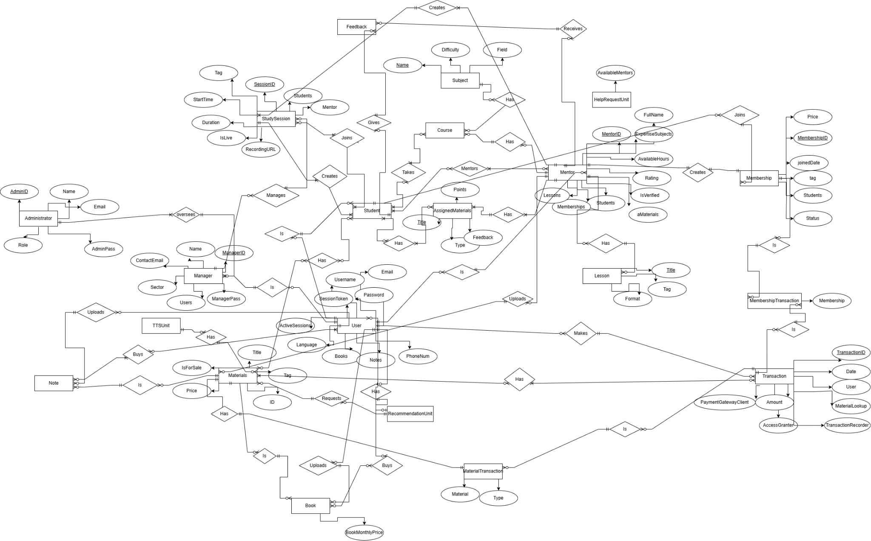

## 5.2 Use Case Diagram

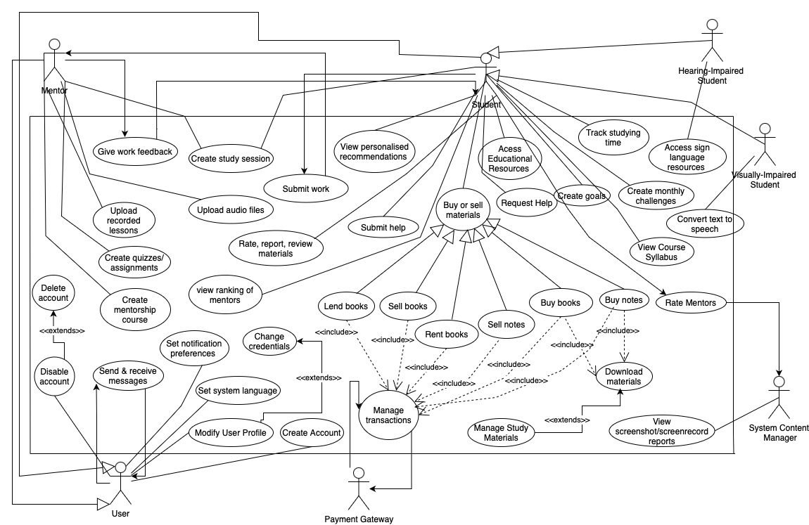

## 5.3 Activity Diagrams

UC_01- Jagoda

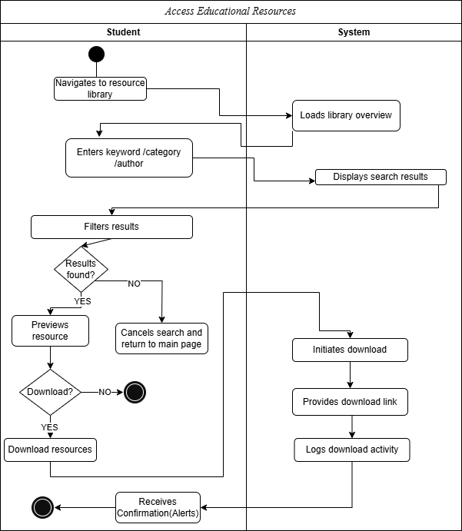

UC_02 - Jagoda

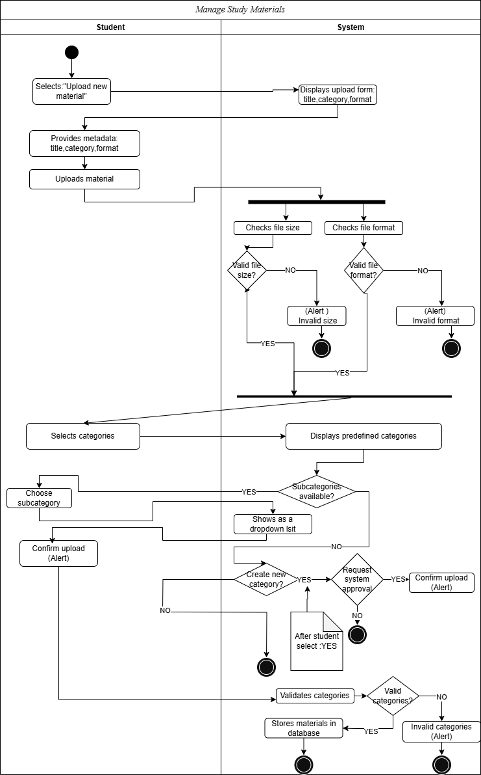

UC_03 - Jagoda

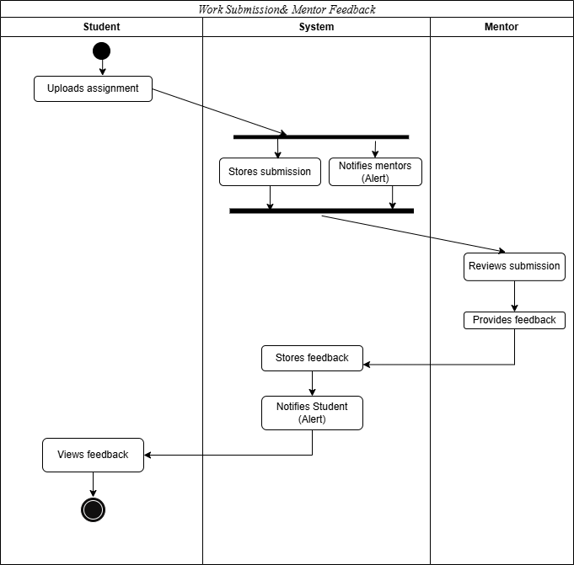

UC_04 - Jagoda

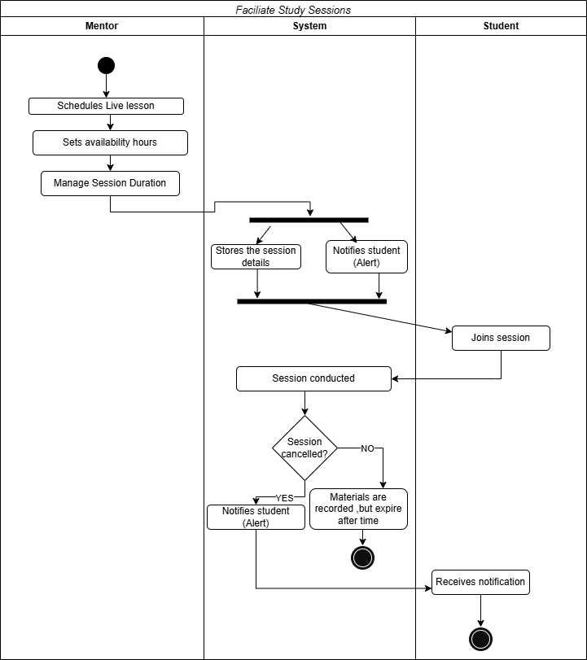

UC_05 - Jagoda

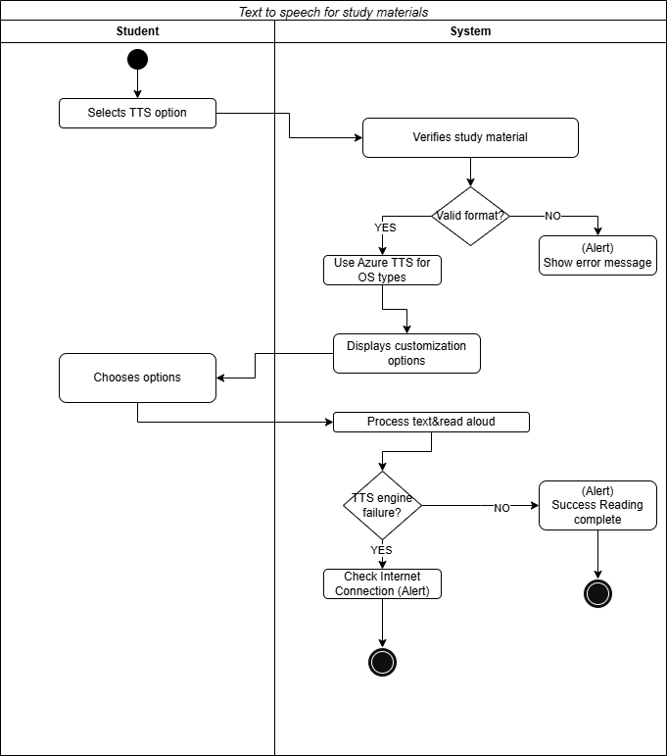

UC_06 - Halil

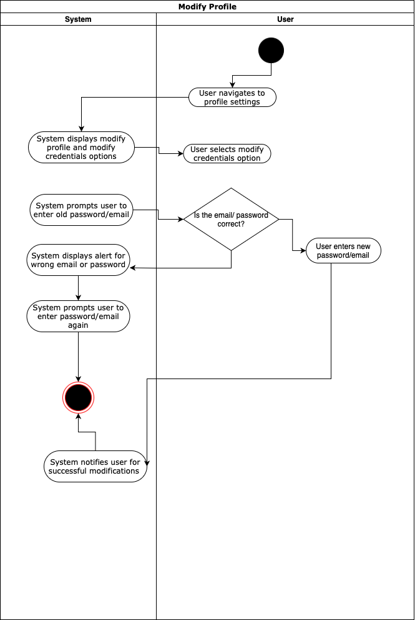

UC_7 - Dionis

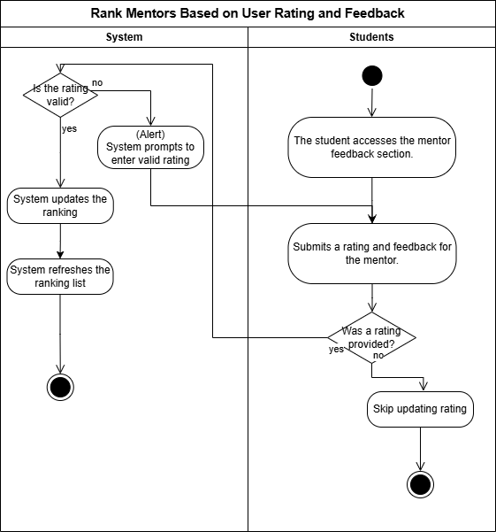

UC_8 - Dionis

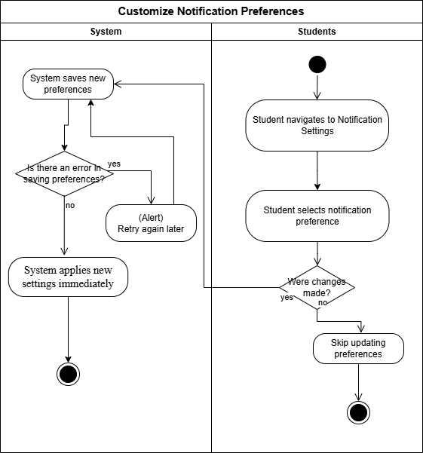

UC_9 - Dionis

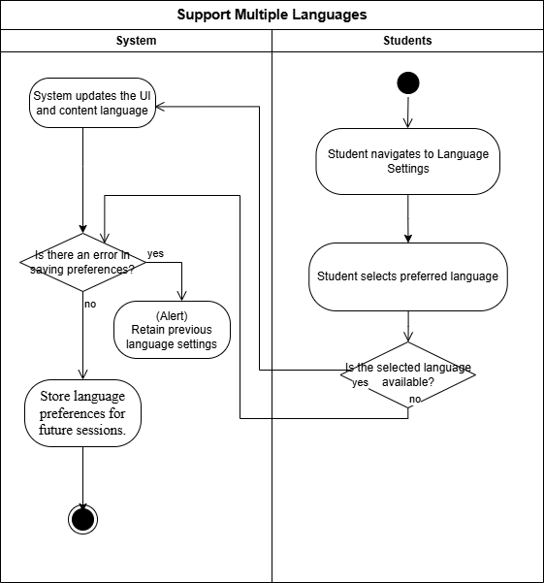

UC_10 - Dionis

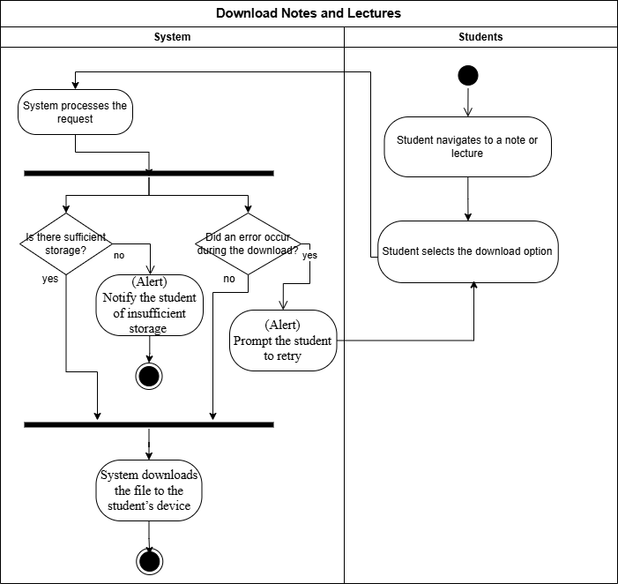

UC_11- Dionis

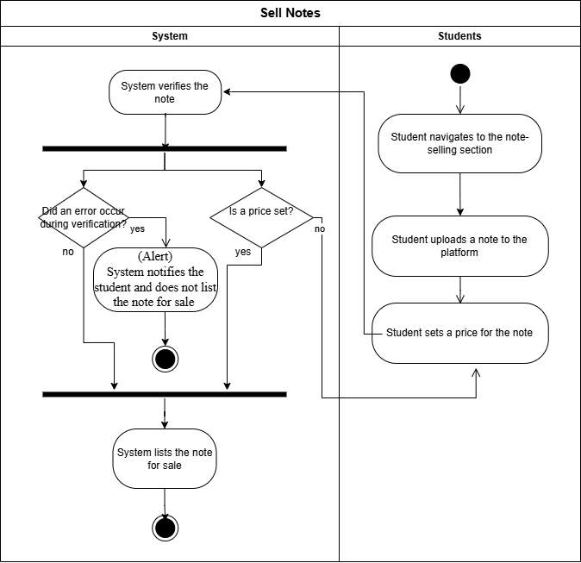

UC_12 - Marvi

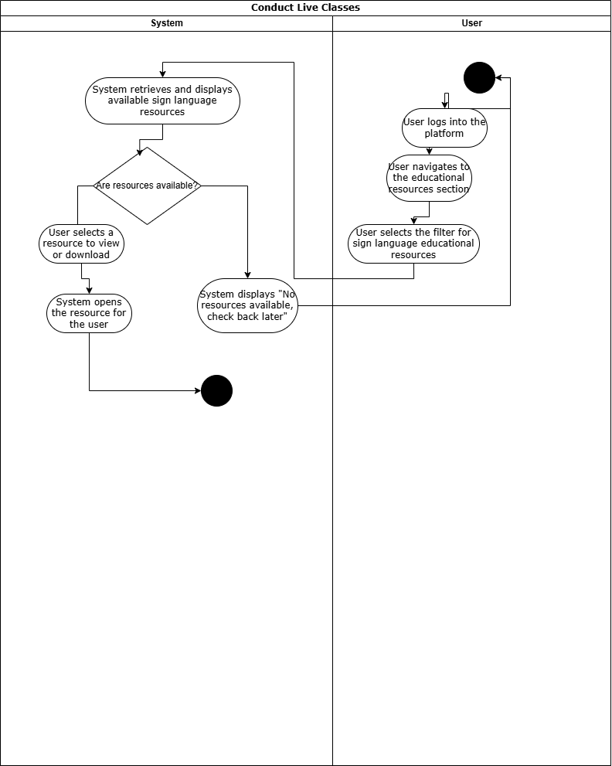

UC_13 - Marvi

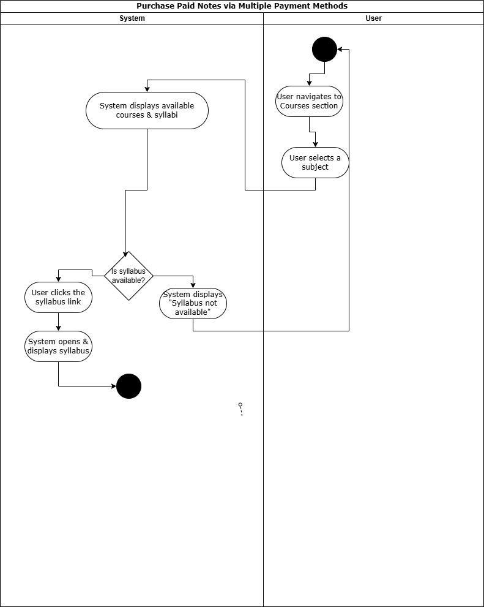

UC_14 - Marvi

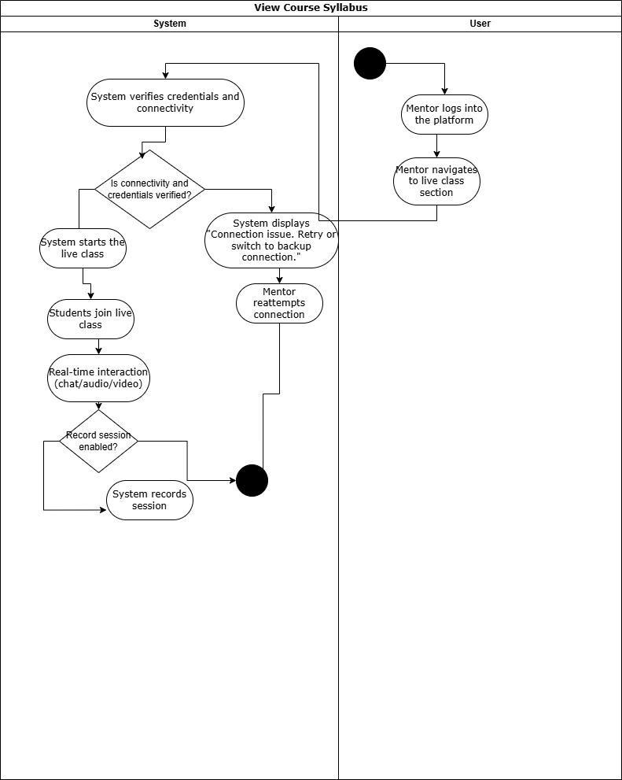

UC_15 - Halil

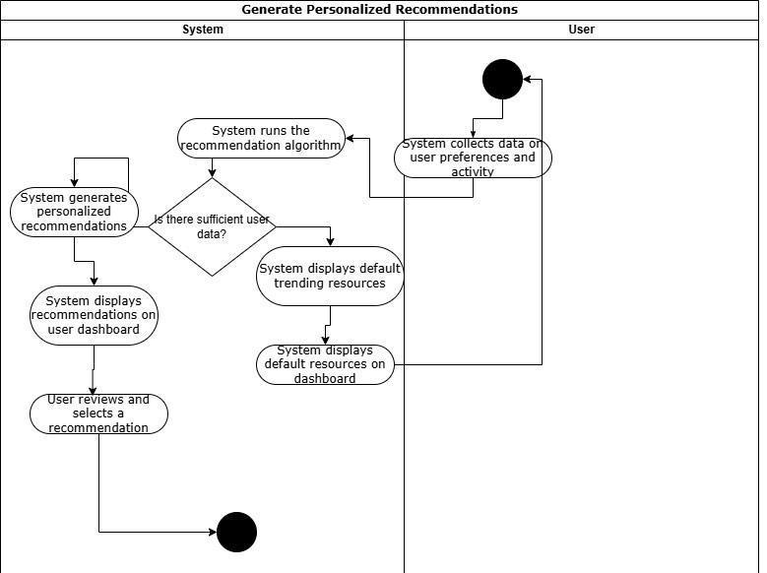

UC_16 - Marvi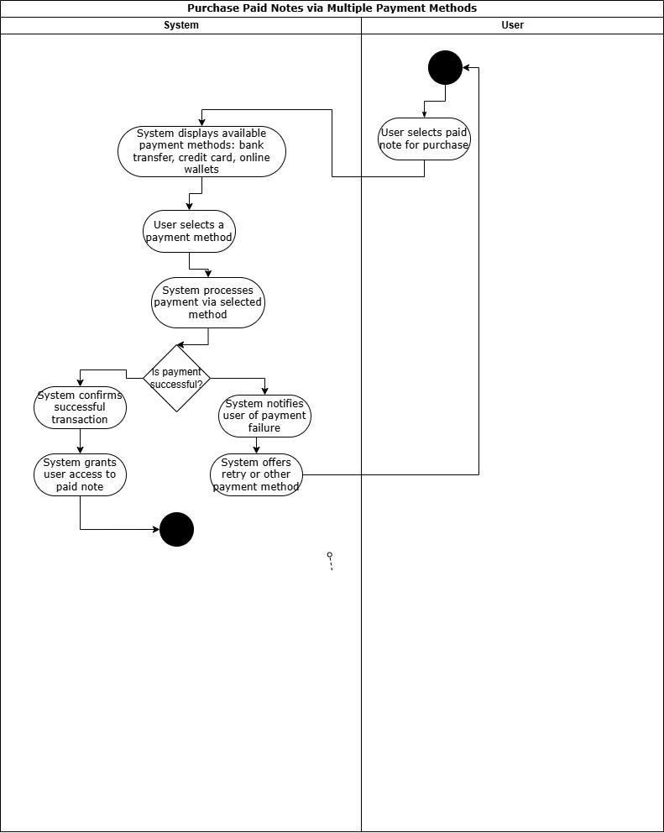

UC_17 - Marvi

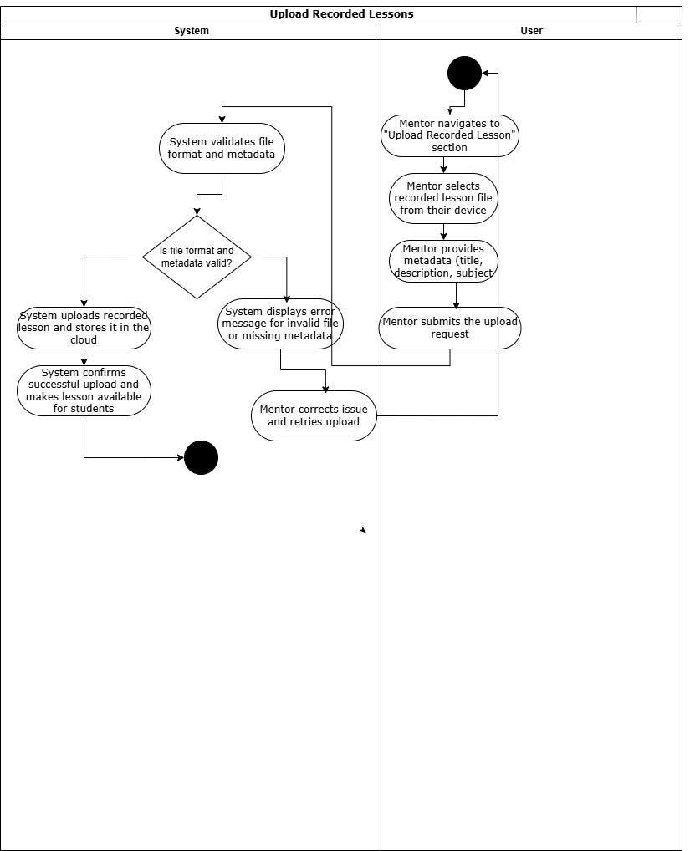

UC_18 - Dea

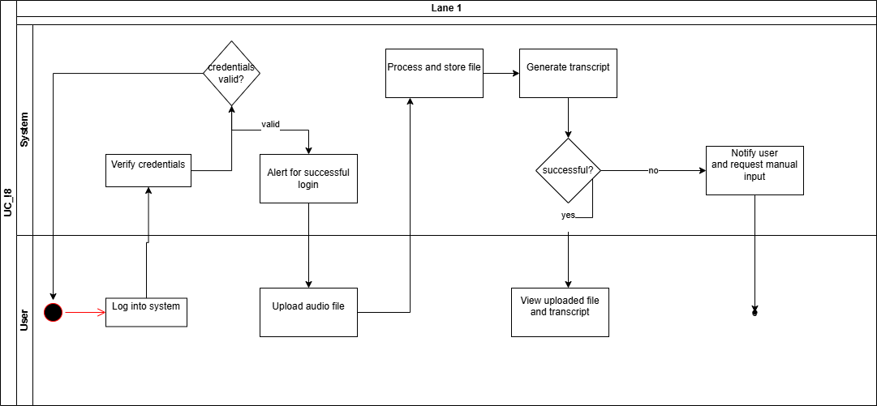

UC_19 - Dea

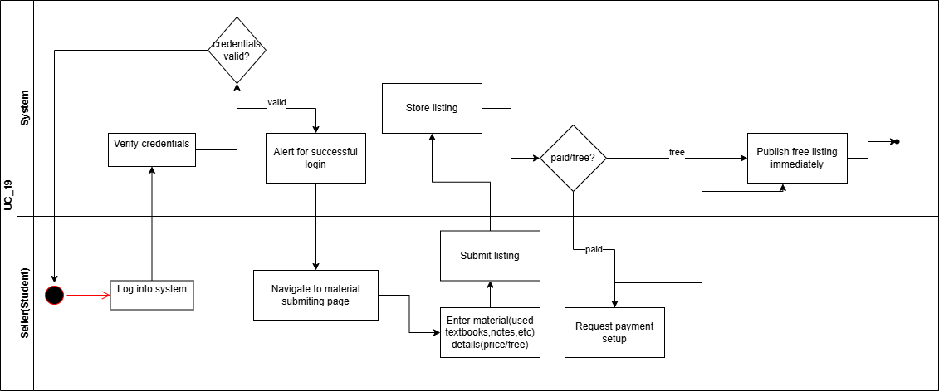

UC_20 - Dea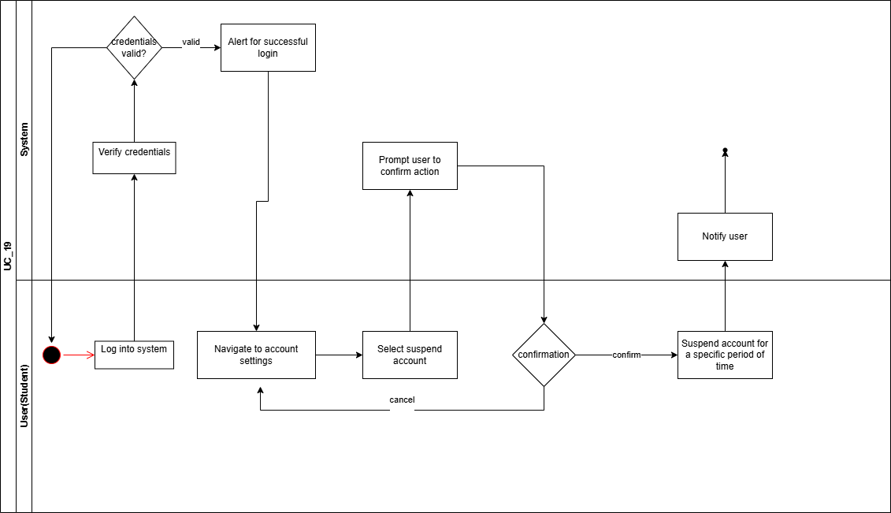

UC_21 - Dea

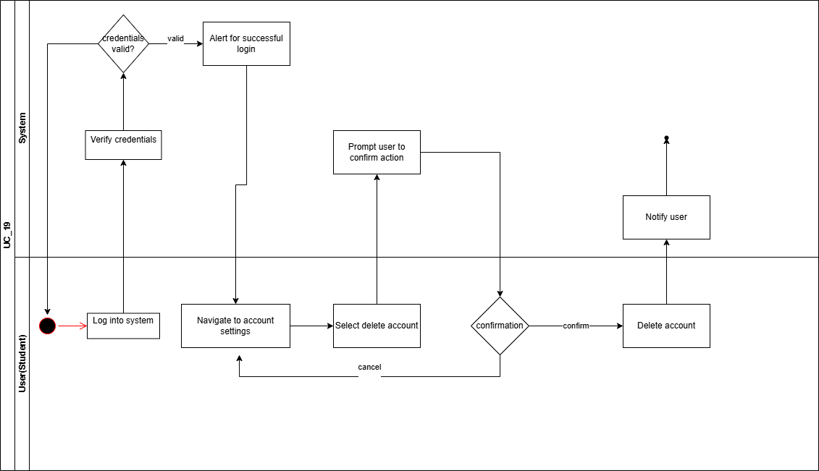

UC_22 - Dea

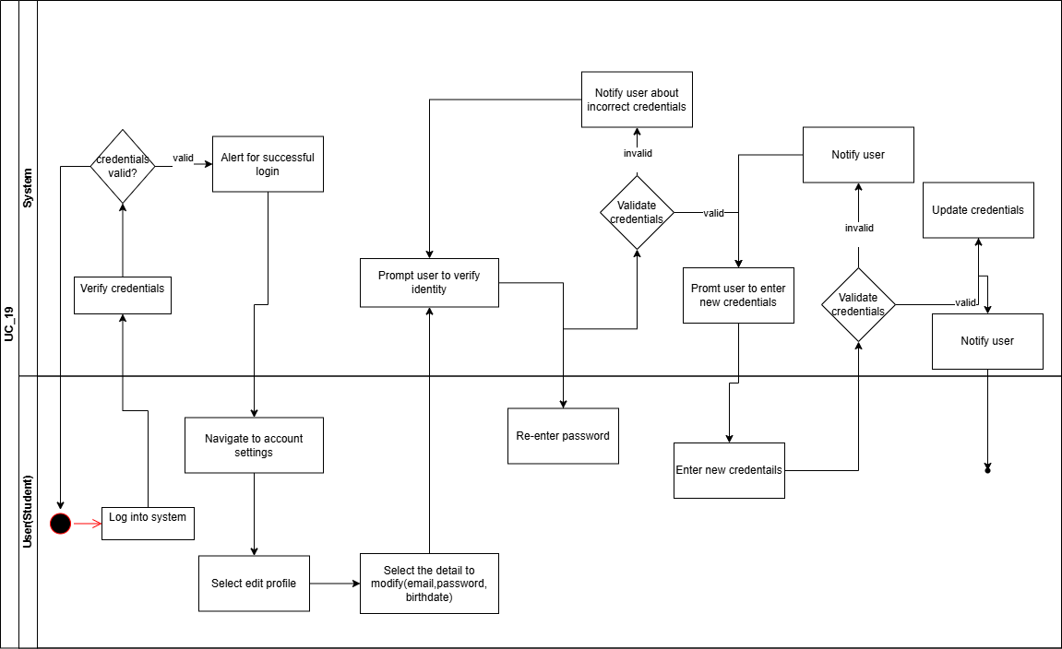

UC_23 - Ameraldo

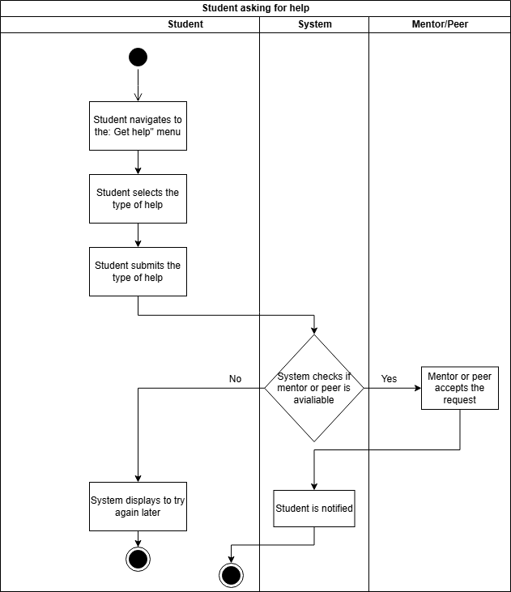

UC_24 - Ameraldo

**Screen Recording/Screenshot prevention Requirement**

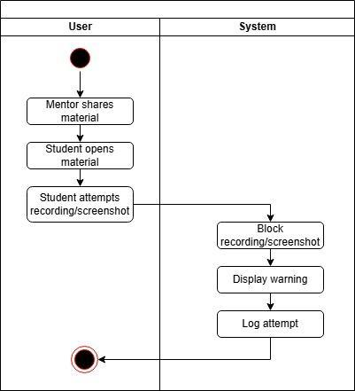

UC_25 - Ameraldo

Rate/Review/Report Requirement

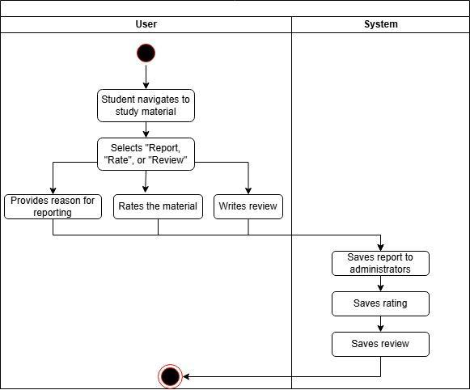

UC_26 - Ameraldo

Goal setting Requirement

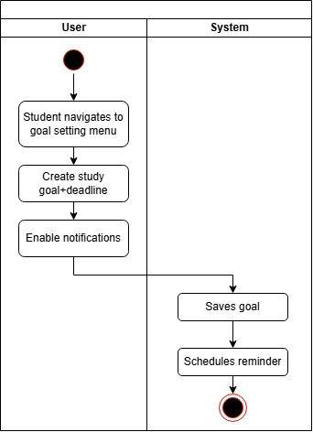

UC_27 - Ameraldo

Student bookmarks material Requirement

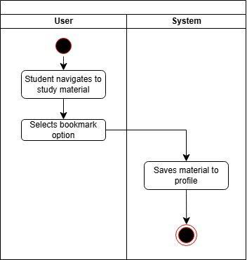

UC_28 - Daniela

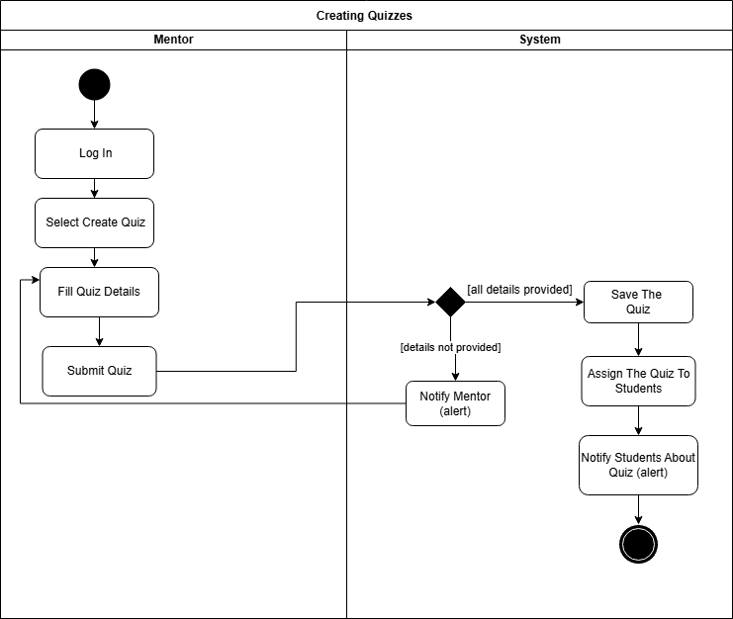

UC_29 - Daniela

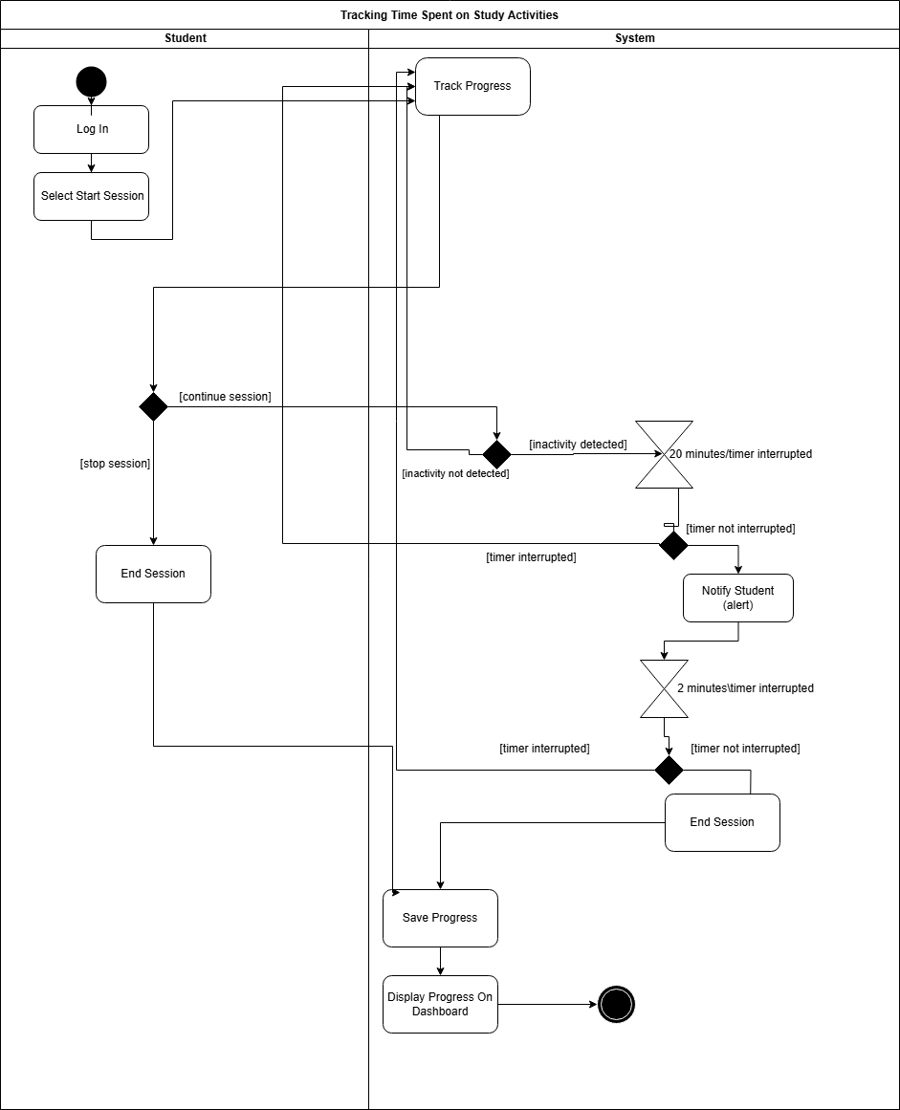

UC_30 - Daniela

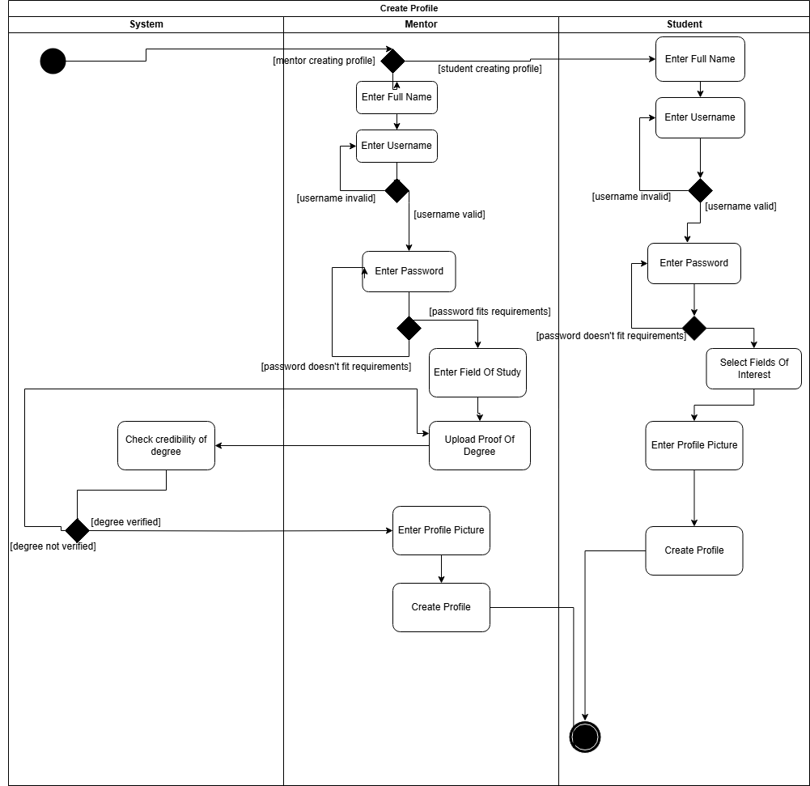

UC_31 - Daniela

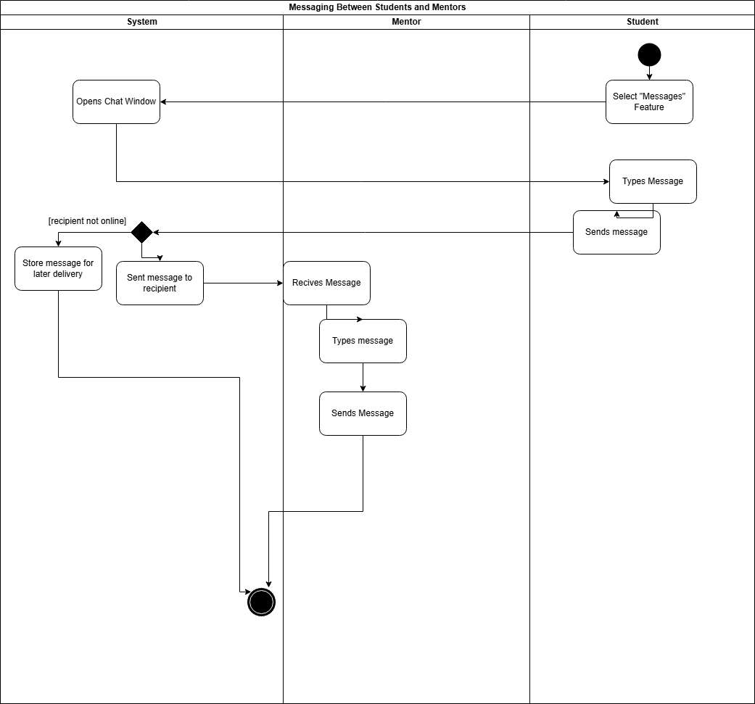

UC_32 - Daniela

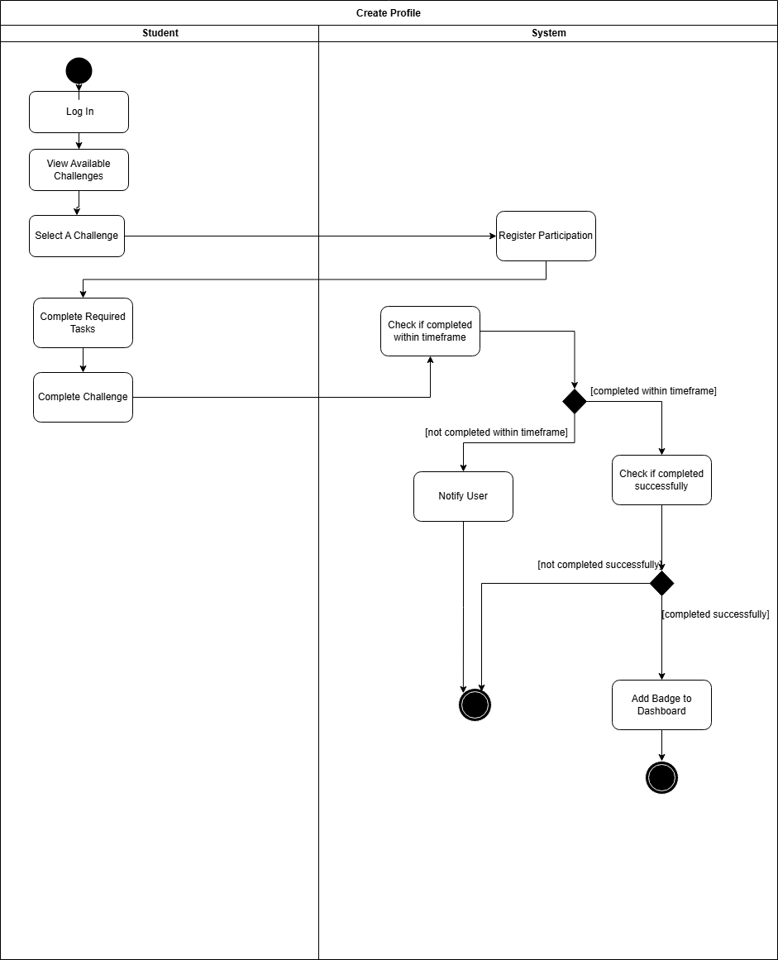

## 5.4 Class Diagram

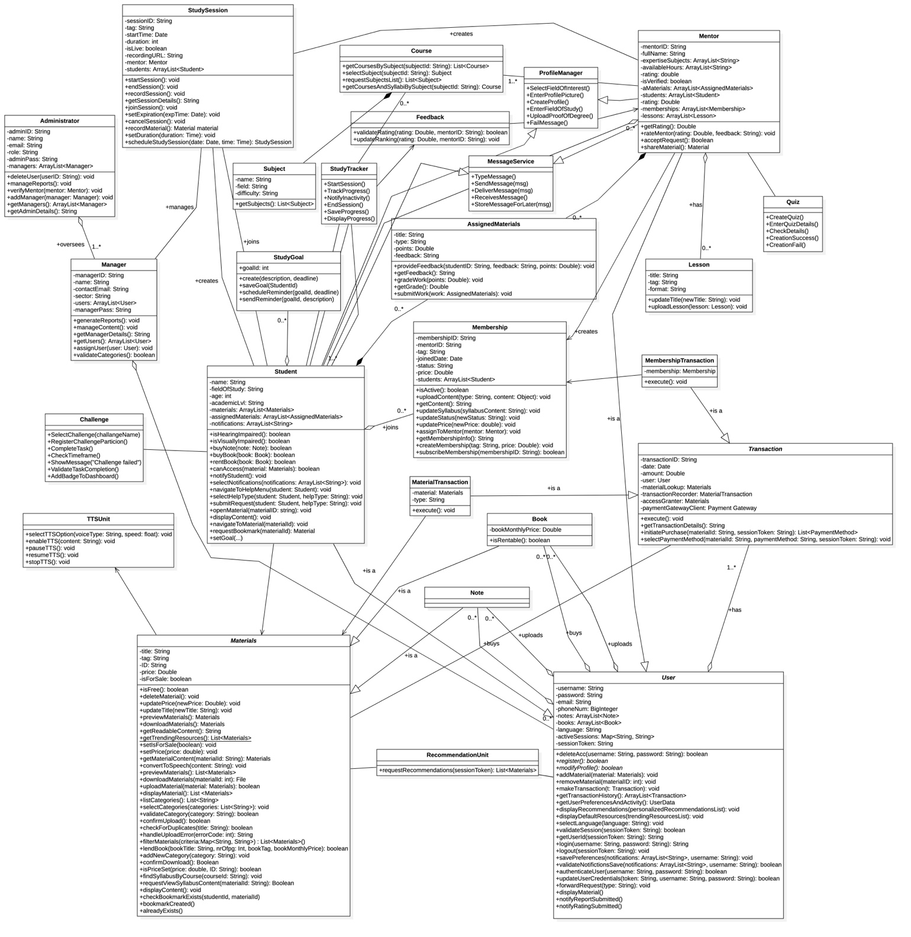

## 5.5 State Diagrams

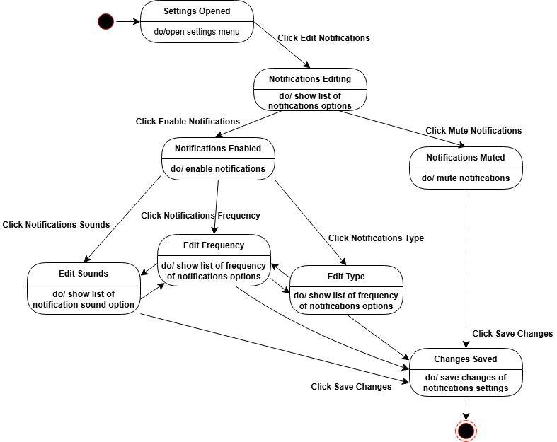

## 

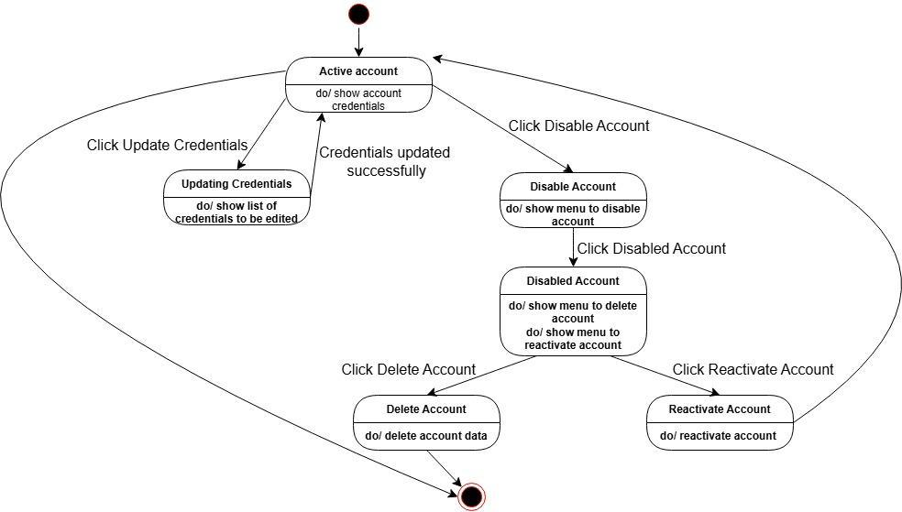

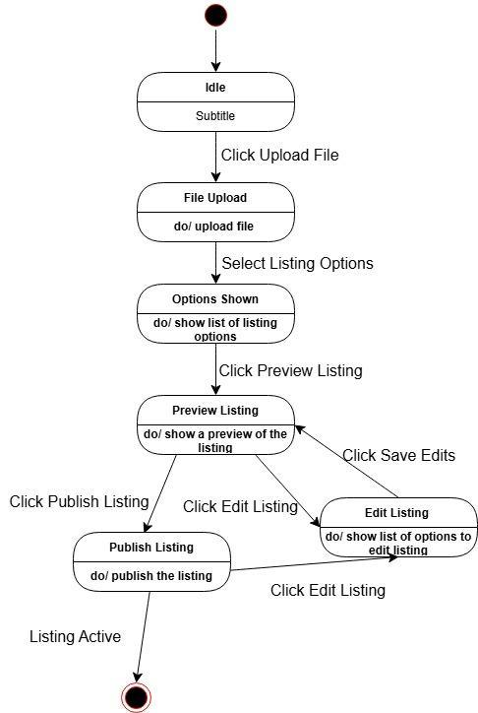

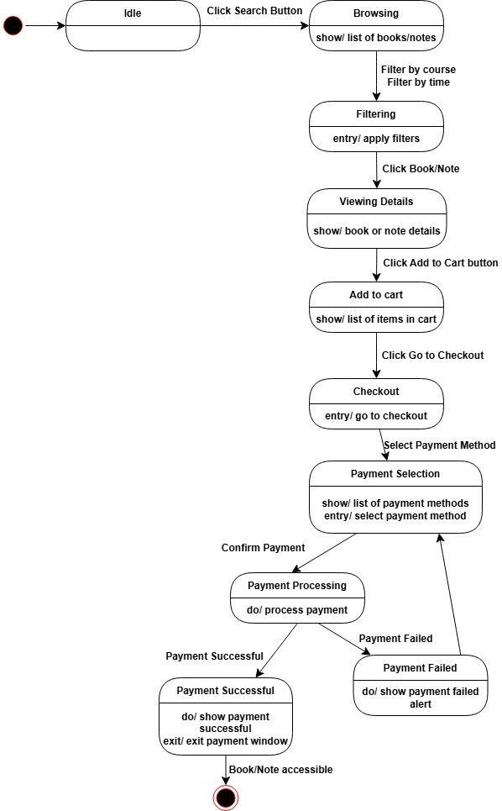

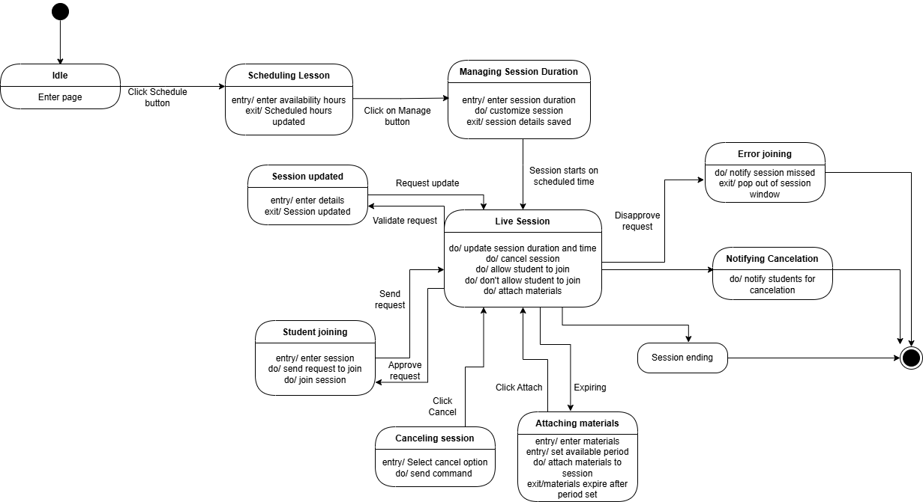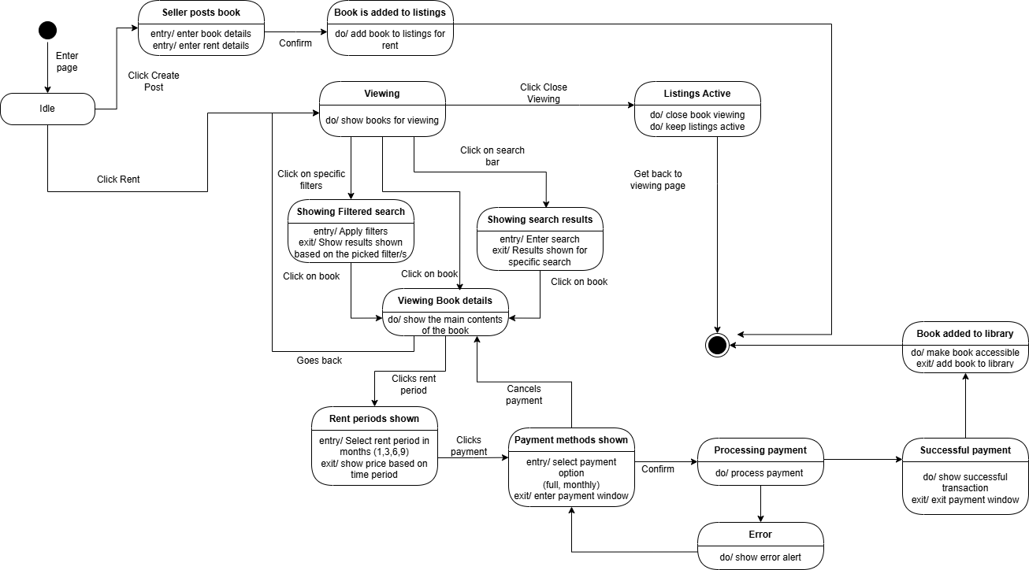

Marvi

## 

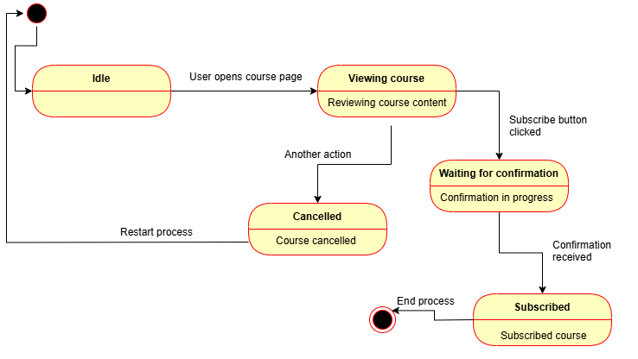

## 5.6 Sequence Diagrams

UC_01- Jagoda Andrea

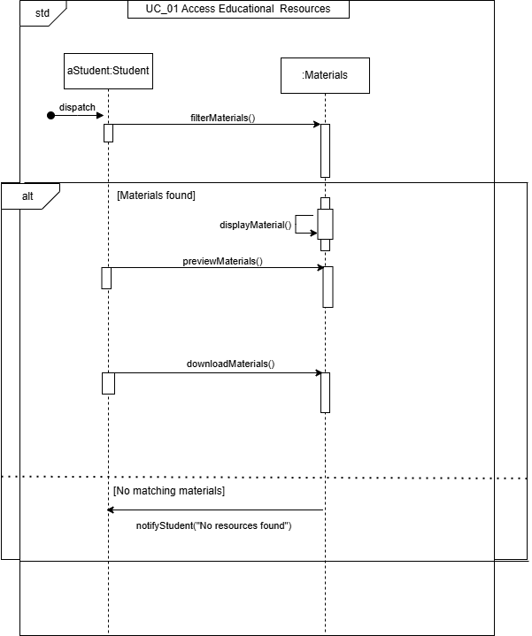

UC_02-Jagoda Andrea

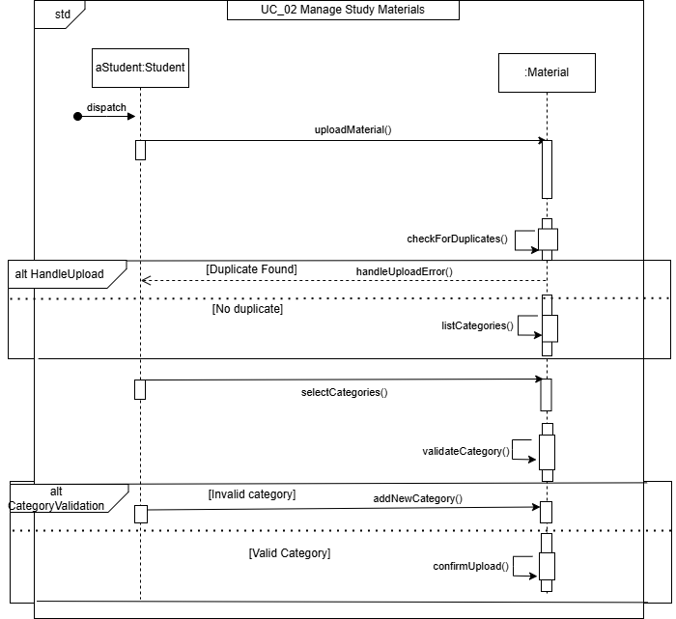

UC_03 -Jagoda Andrea

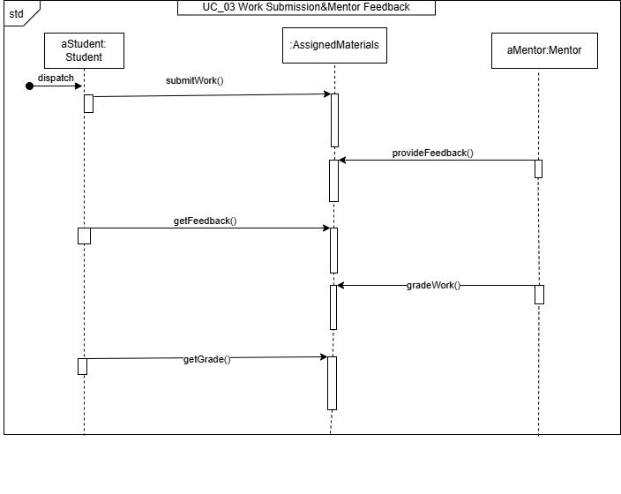

## 

## 

UC_04-Jagoda Andrea

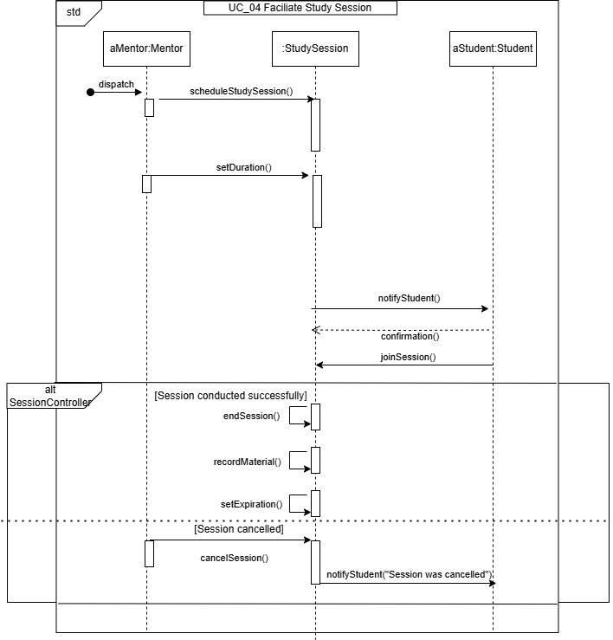

UC_05- Jagoda Andrea

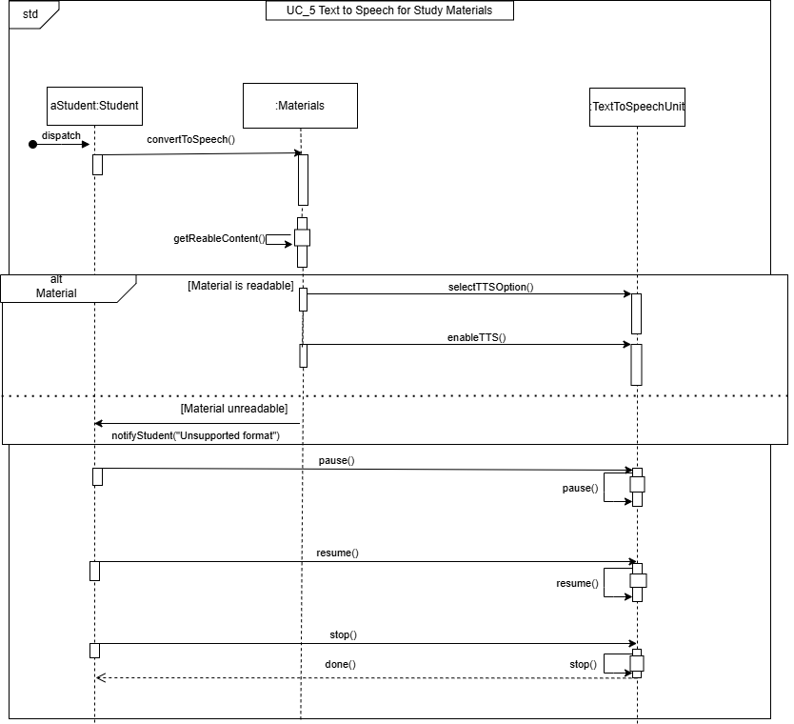

UC_6 – Halil

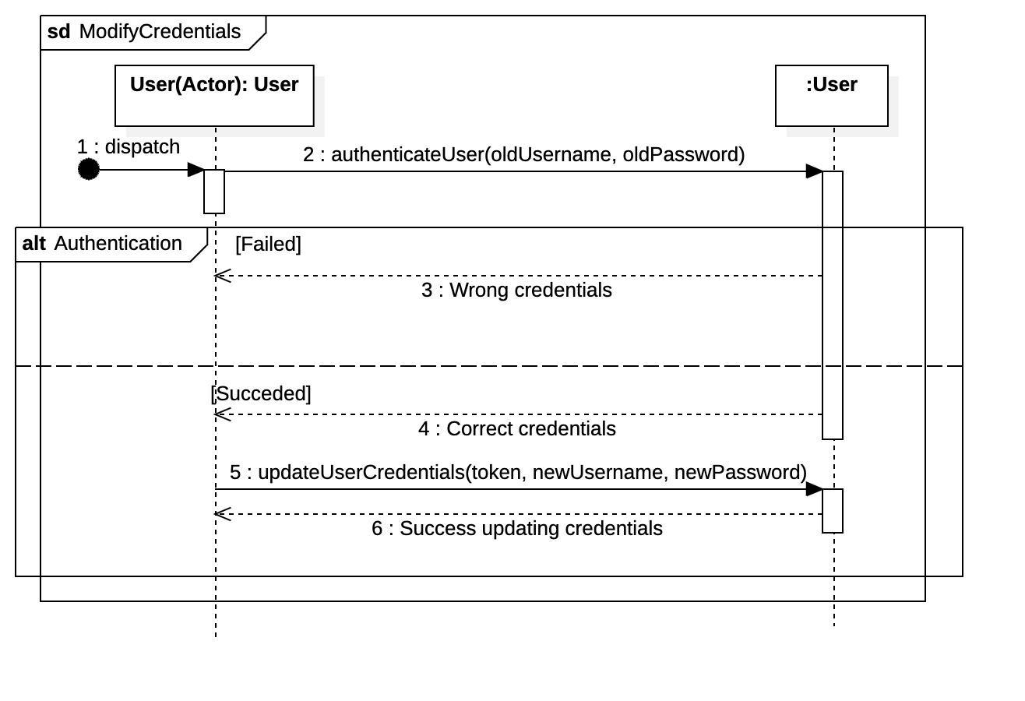

UC_7 - Dionis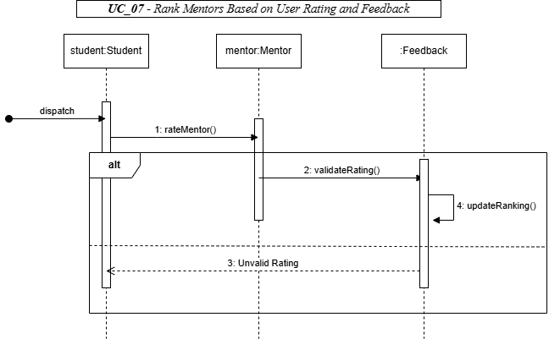

UC_8 - Dionis

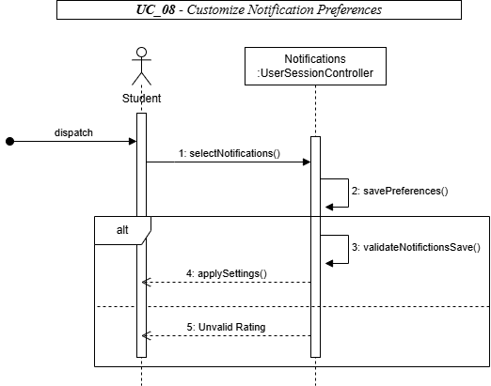

UC_9 - Dionis

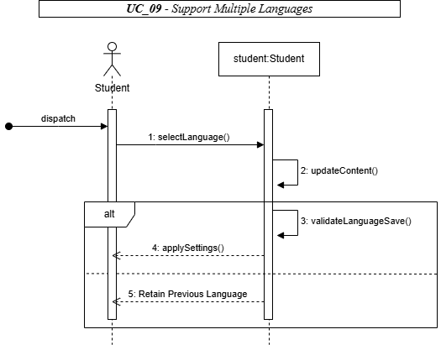

UC_10 - Dionis

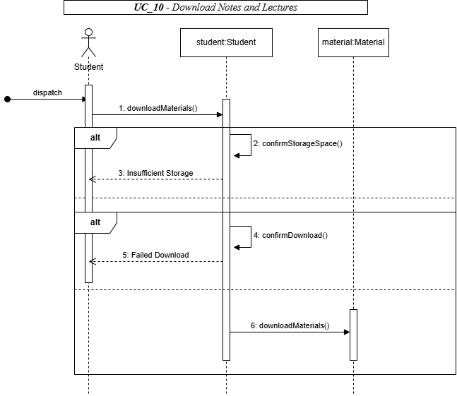

UC_11 - Dionis

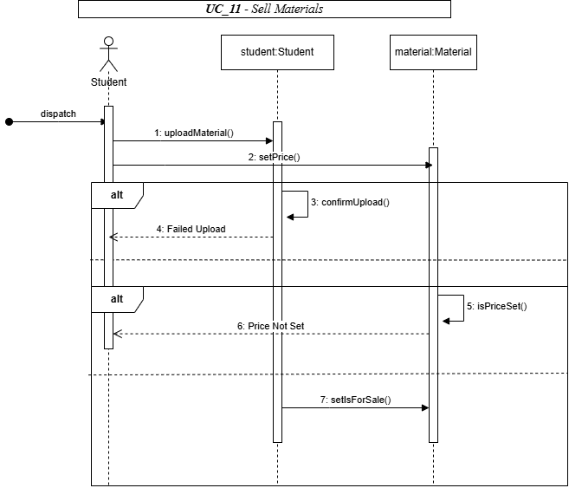

UC_12 - Marvi

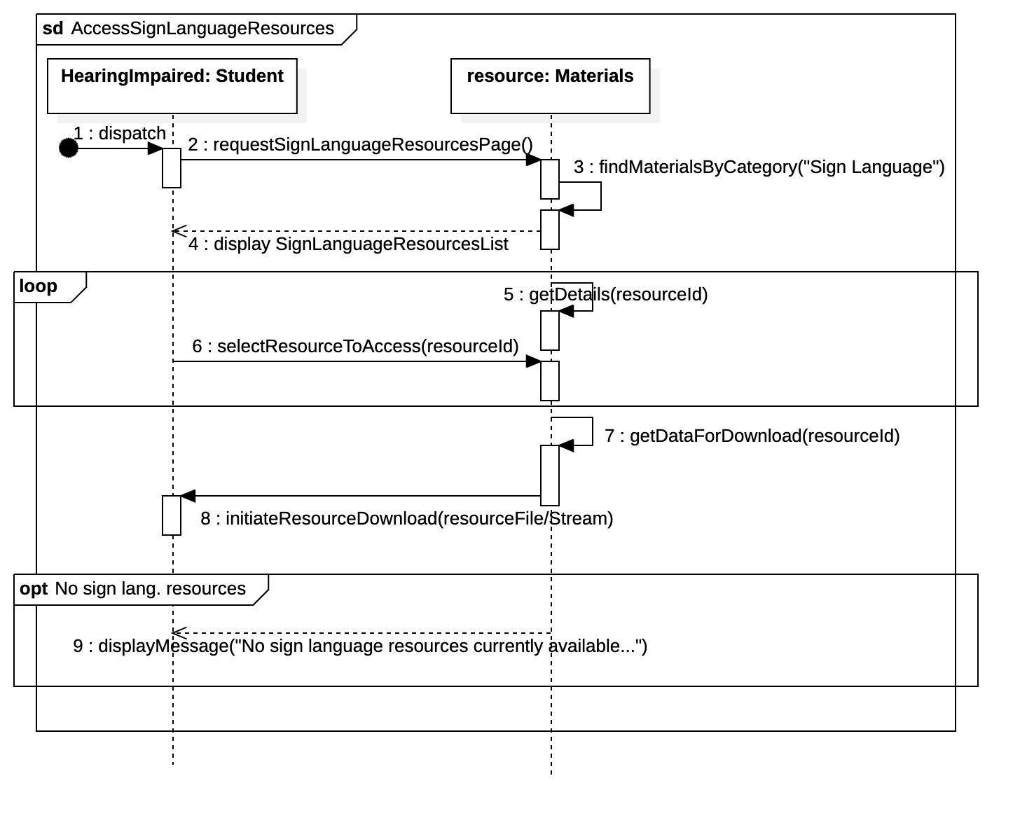

UC_13 - Marvi

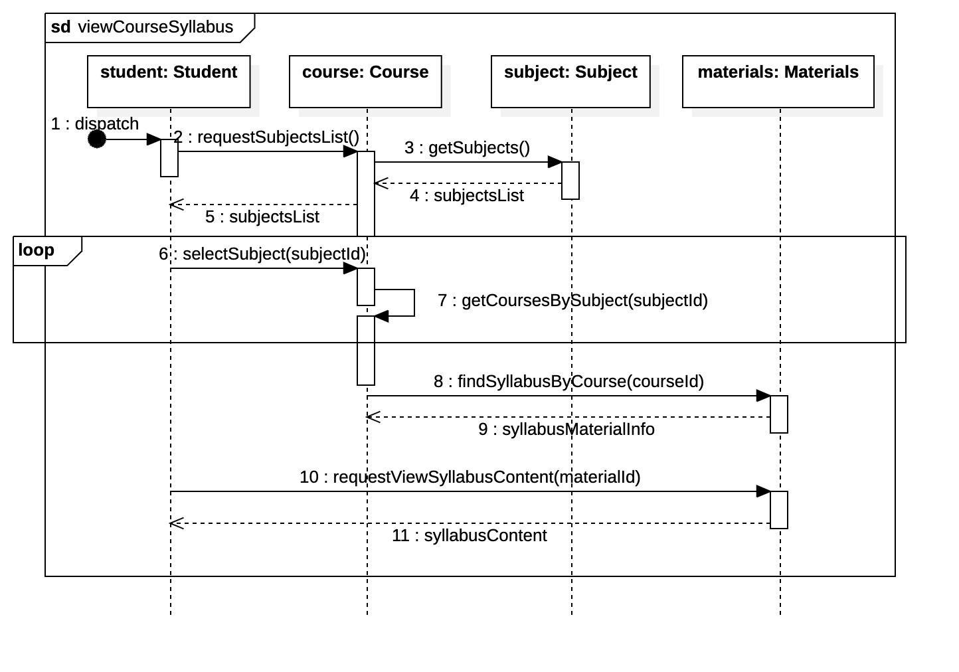

UC_14 - Halil

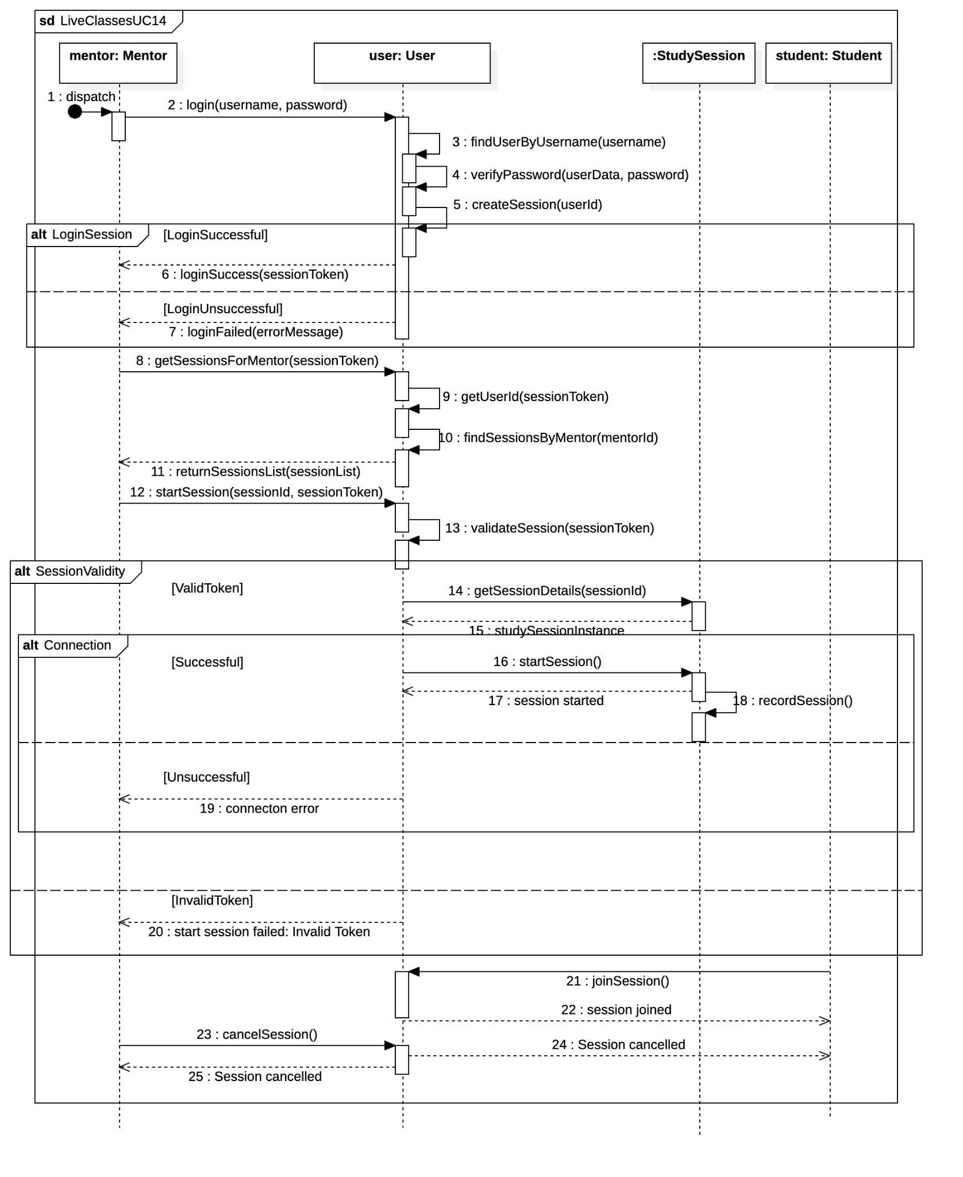

UC_15 - Halil

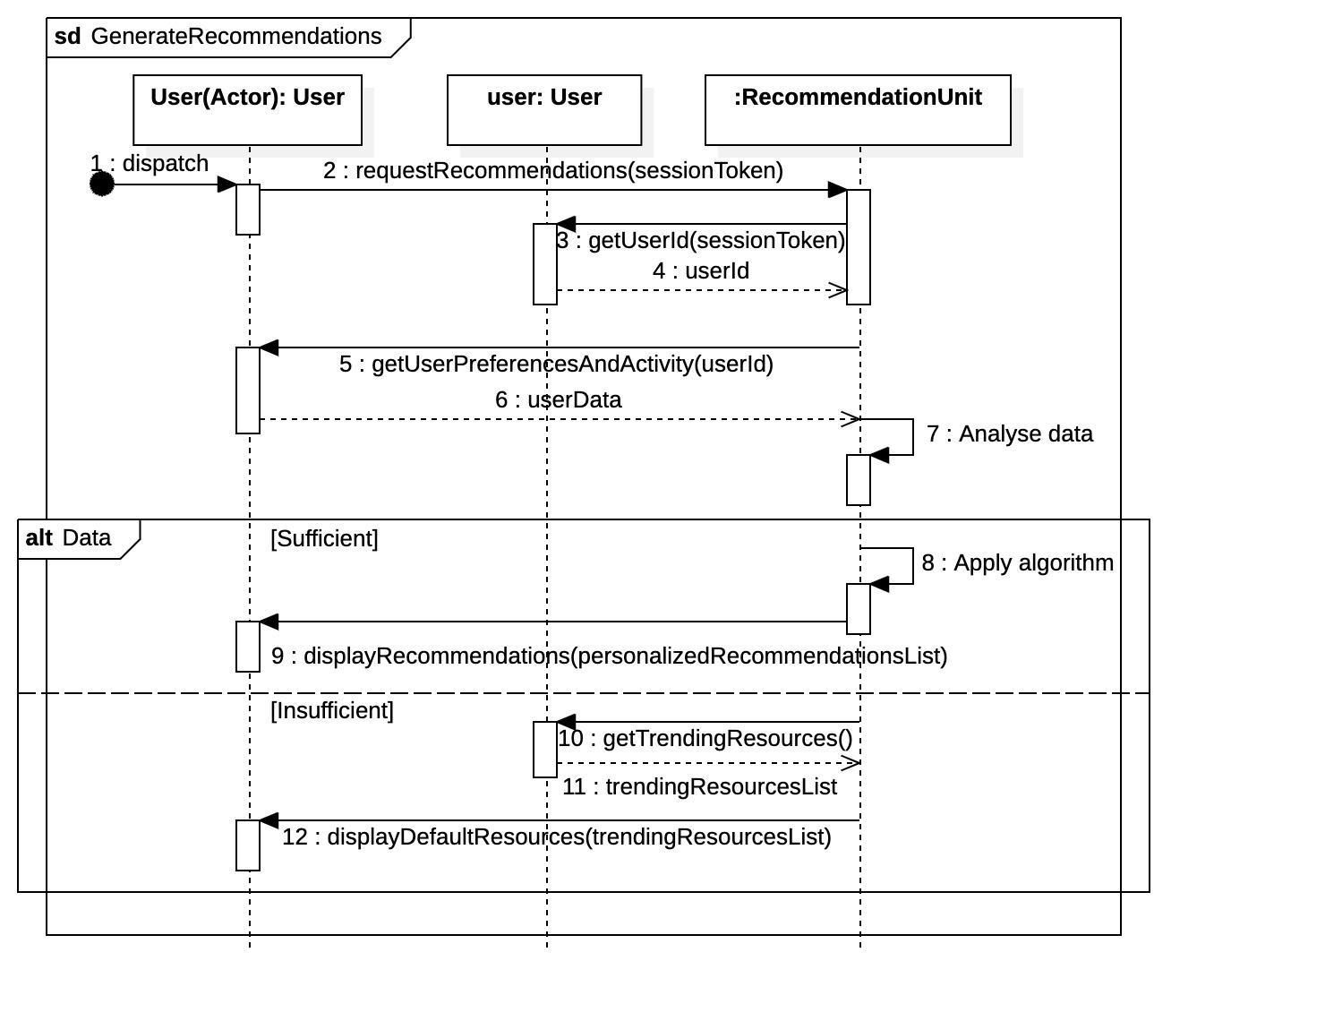

UC_16 - Purchase Materials via multiple payment methods – Halil

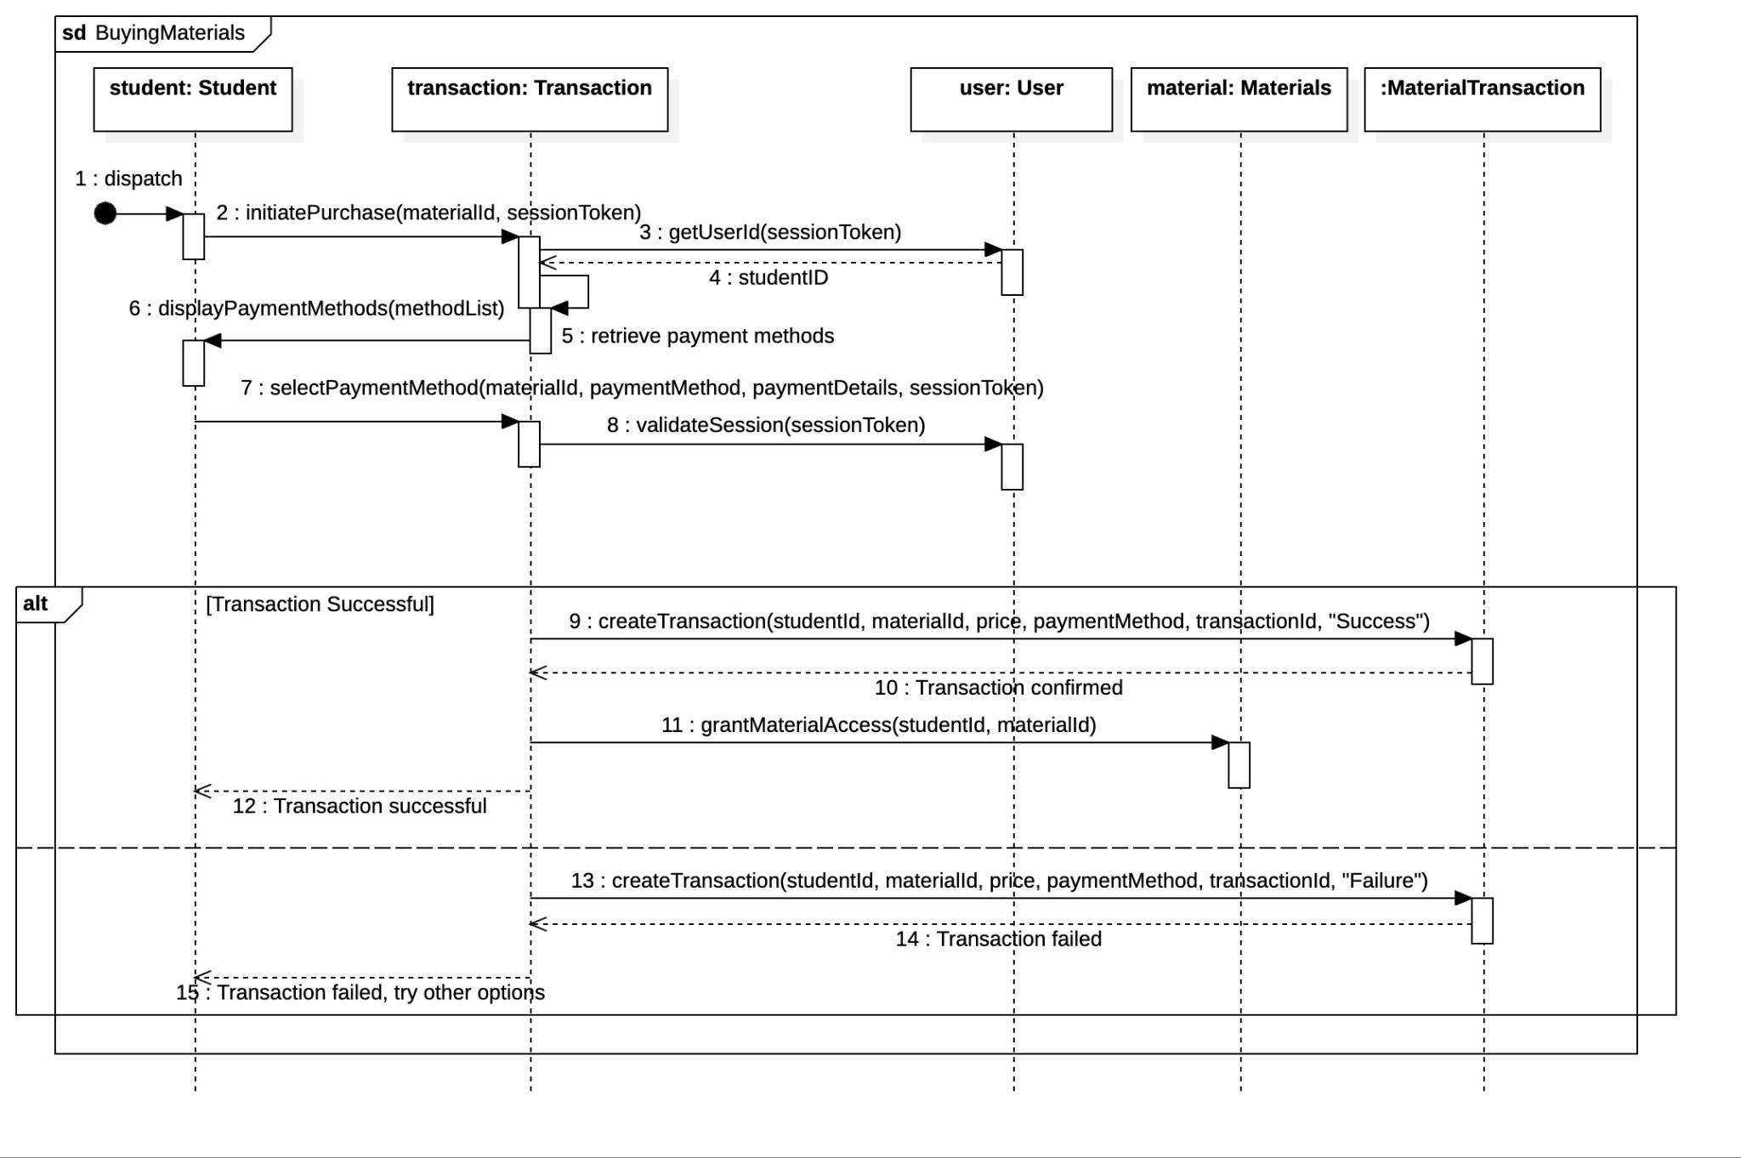

UC_17 - Halil

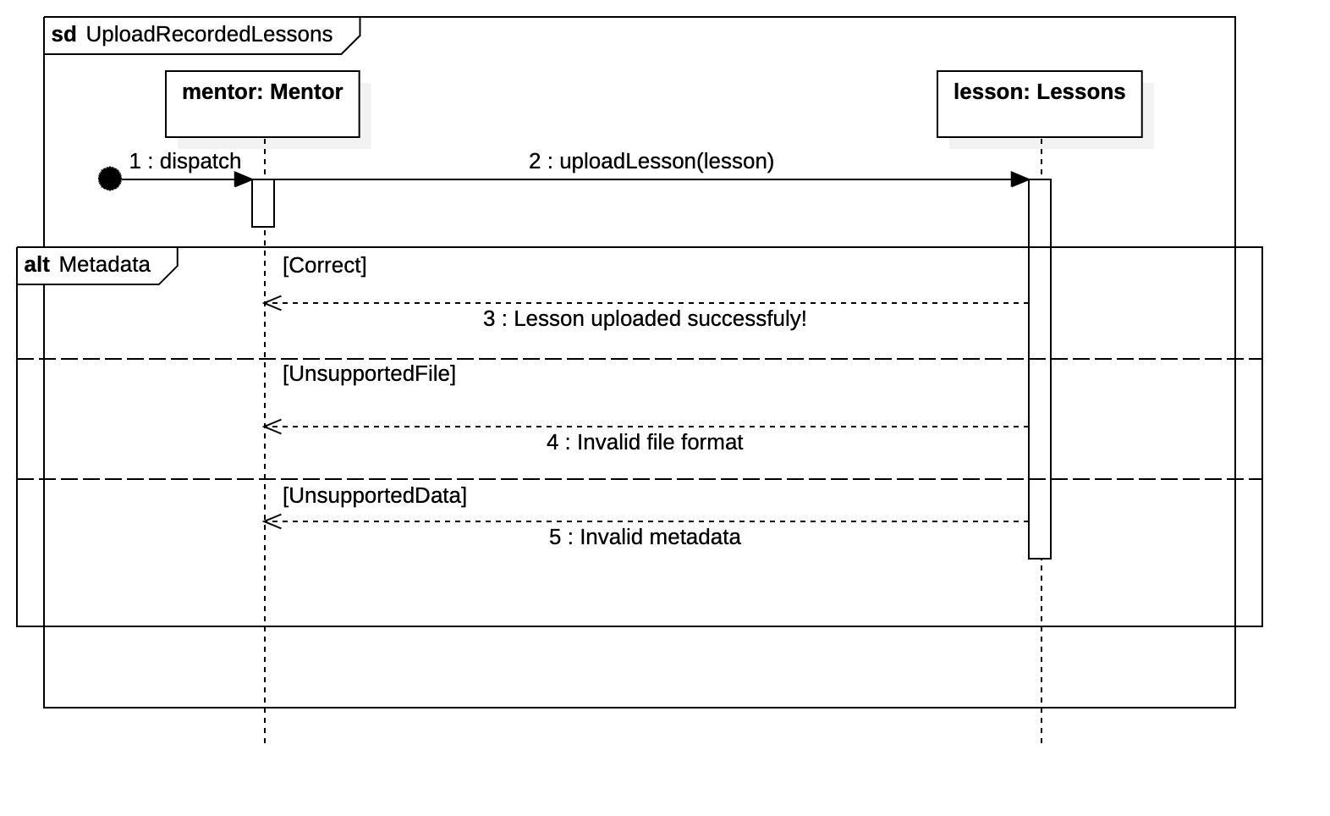

UC_18 - Dea

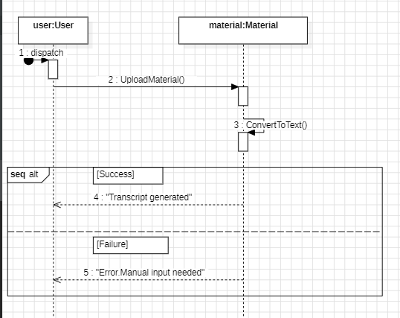

Uc_19 - Account deletion- Dea

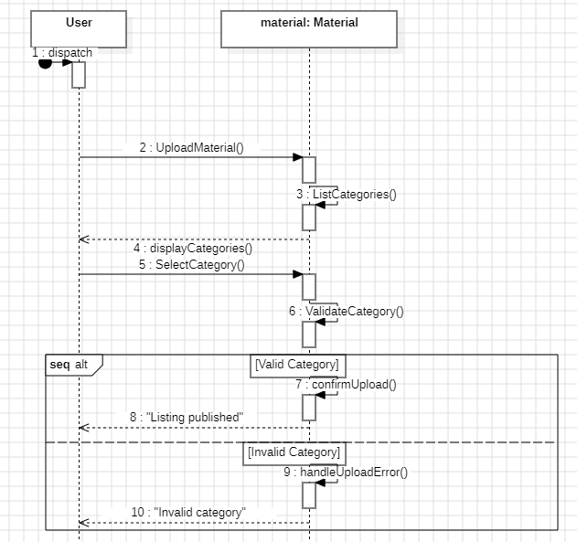

SC_20

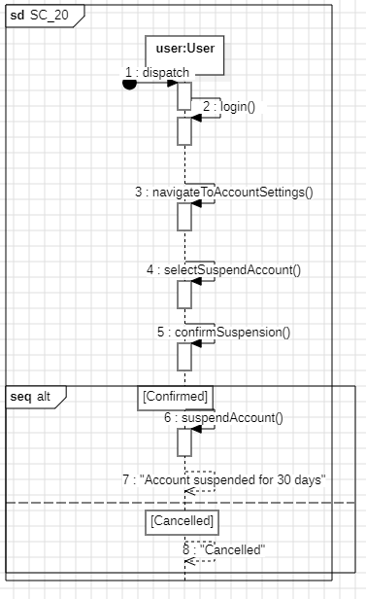

SC_21

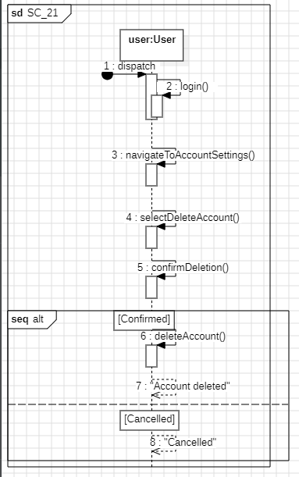

SC_22

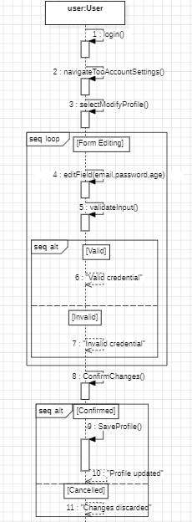

UC 23 Ameraldo

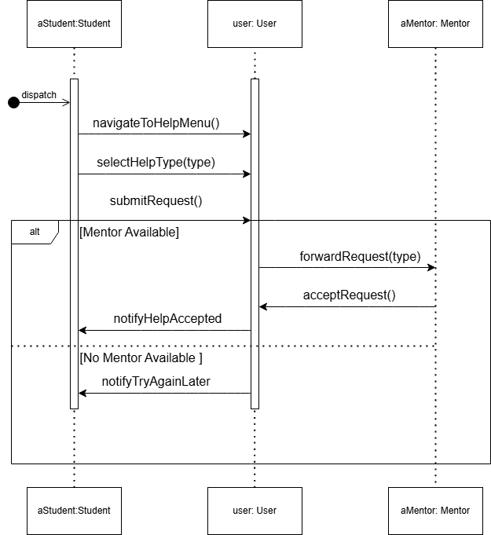

UC 24 - Ameraldo

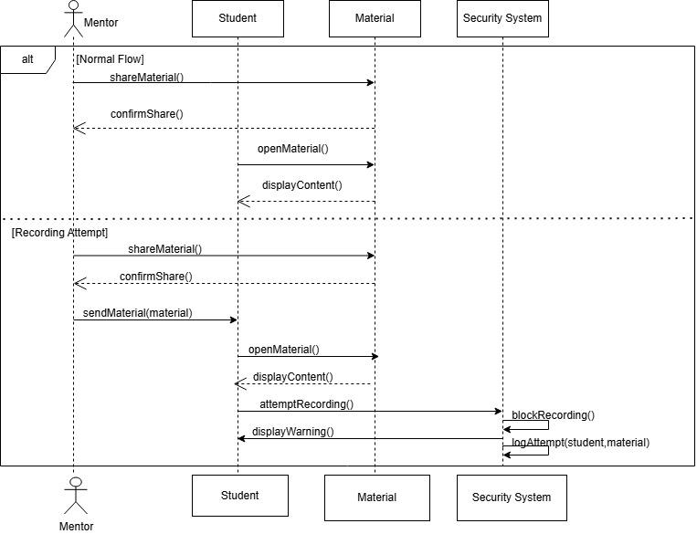

UC 25 Ameraldo

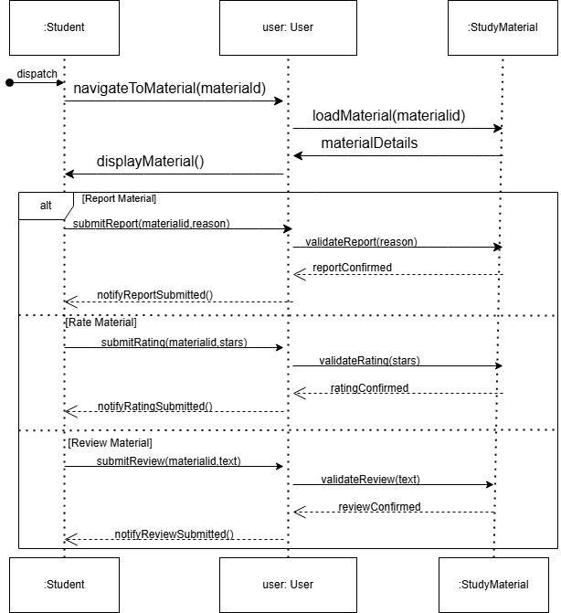

UC 26 Ameraldo

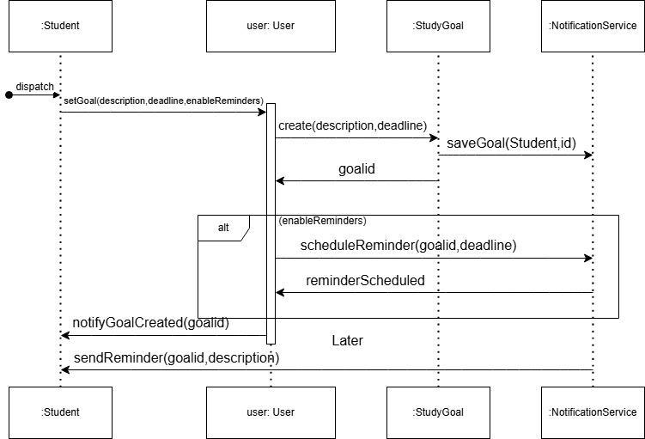

UC 27 Ameraldo

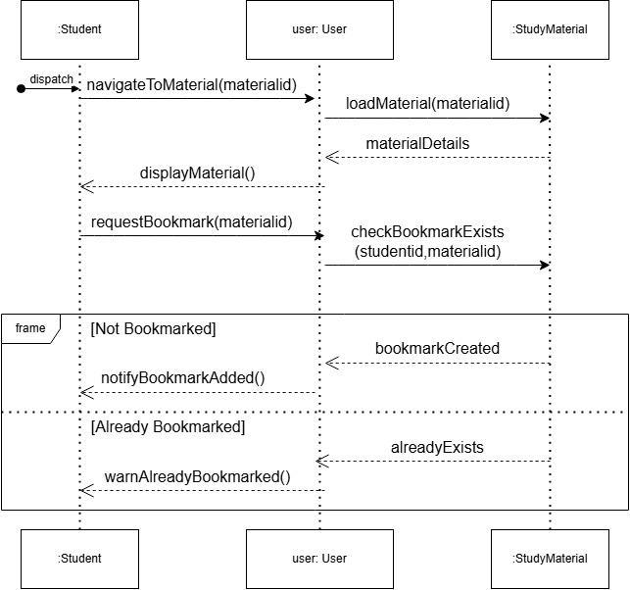

UC 28 Daniela

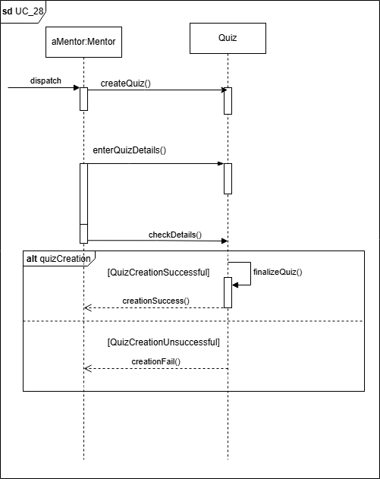

UC 29 Daniela

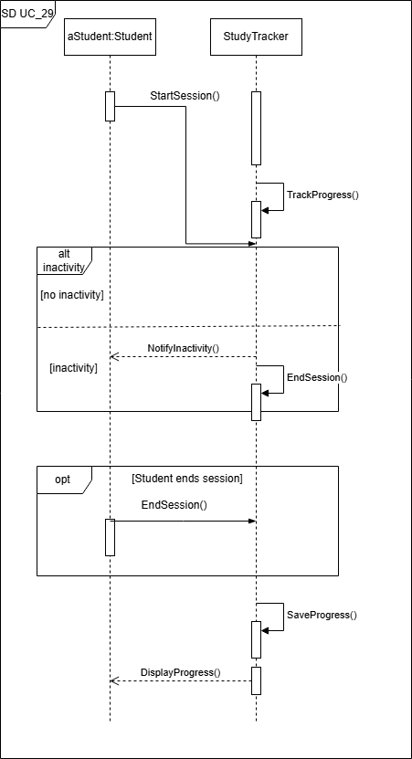

UC 30 Daniela

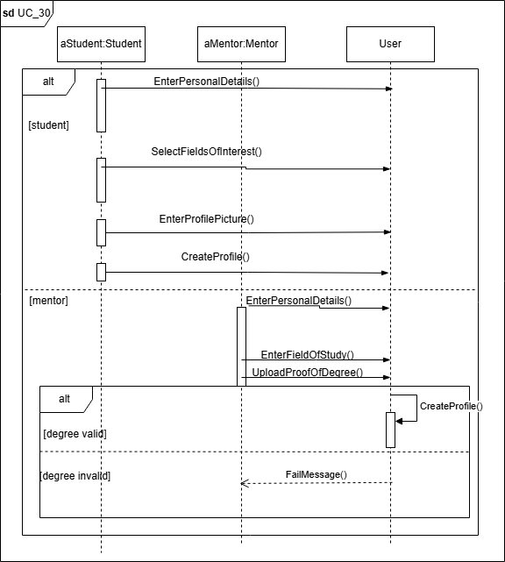

UC 31 Daniela

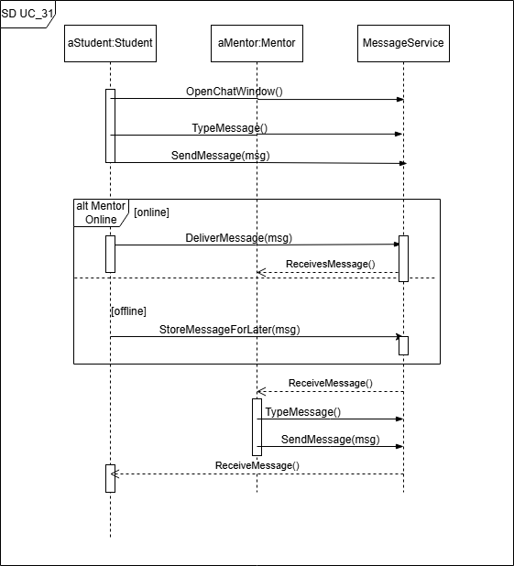

UC 32

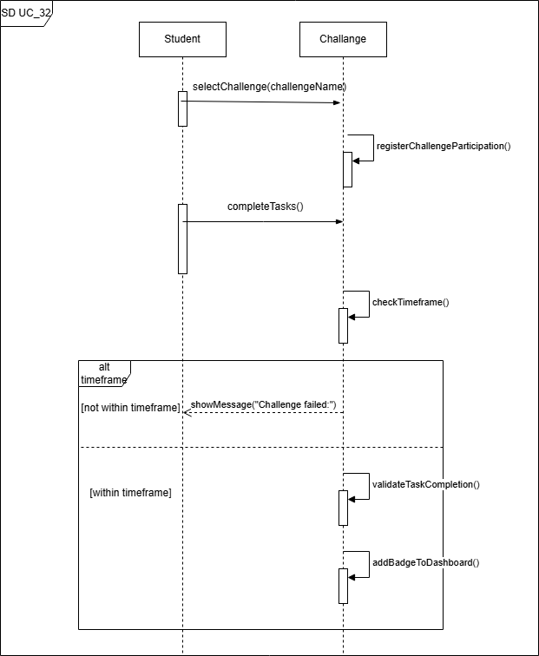

## 5.7 Collaboration diagrams

SD_01 -Jagoda

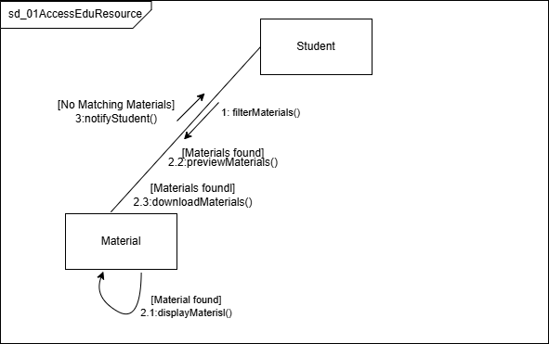

SD_02-Jagoda

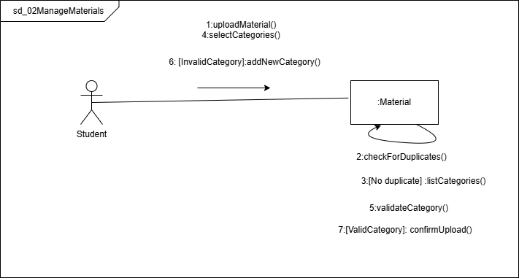

SD_03-Jagoda

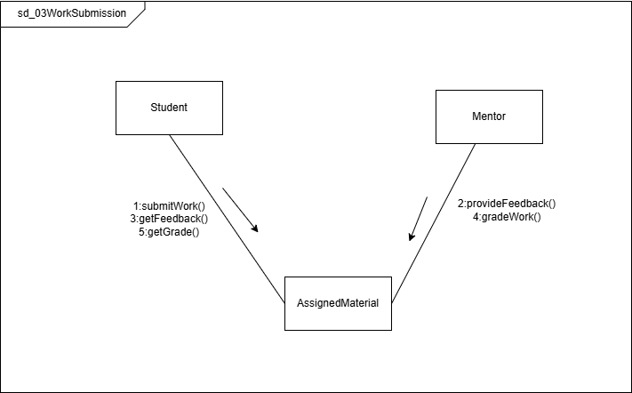

SD_04-Jagoda

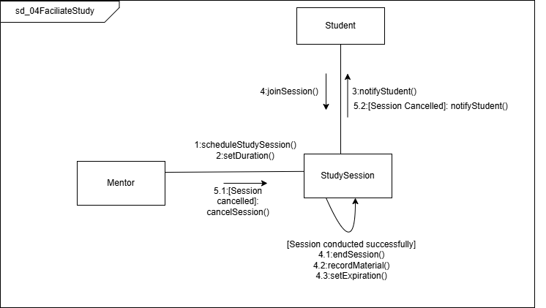

SD_05 -Jagoda

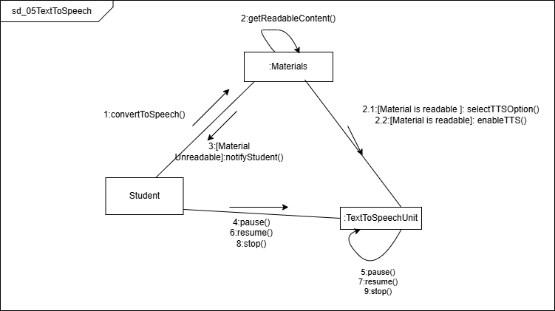

UC_6 - Halil

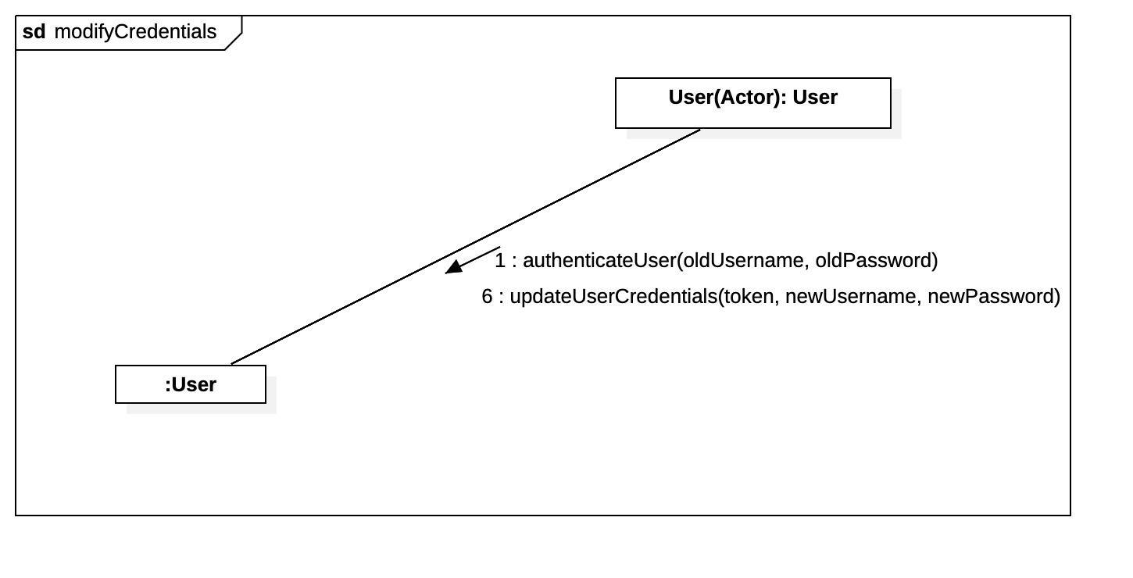

UC_7 - Dionis

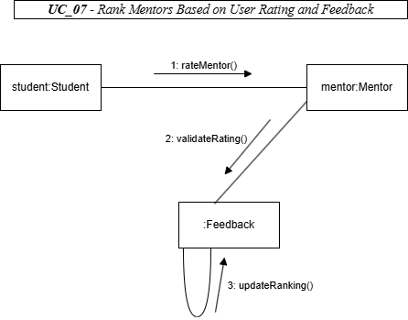

UC_8 - Dionis

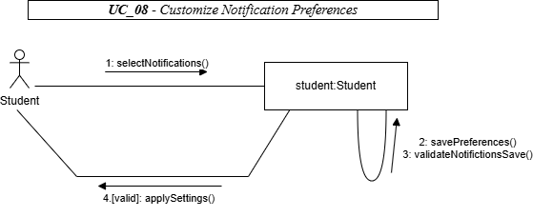

UC_9 - Dionis

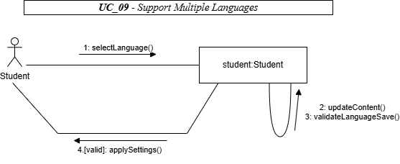

UC_10 - Dionis

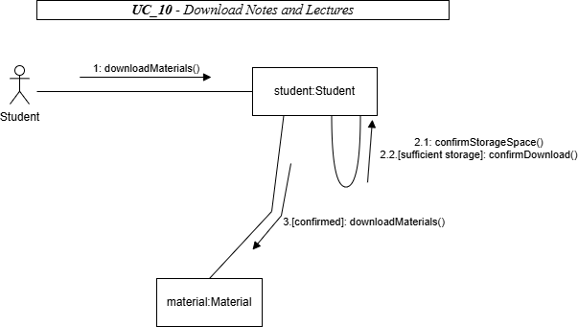

UC_11 - Dionis

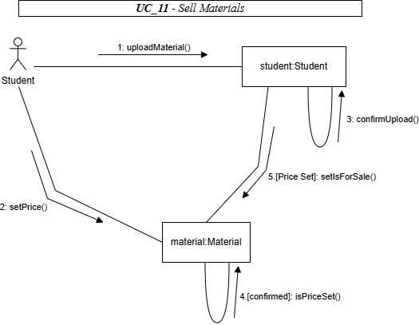

UC_12 - Marvi

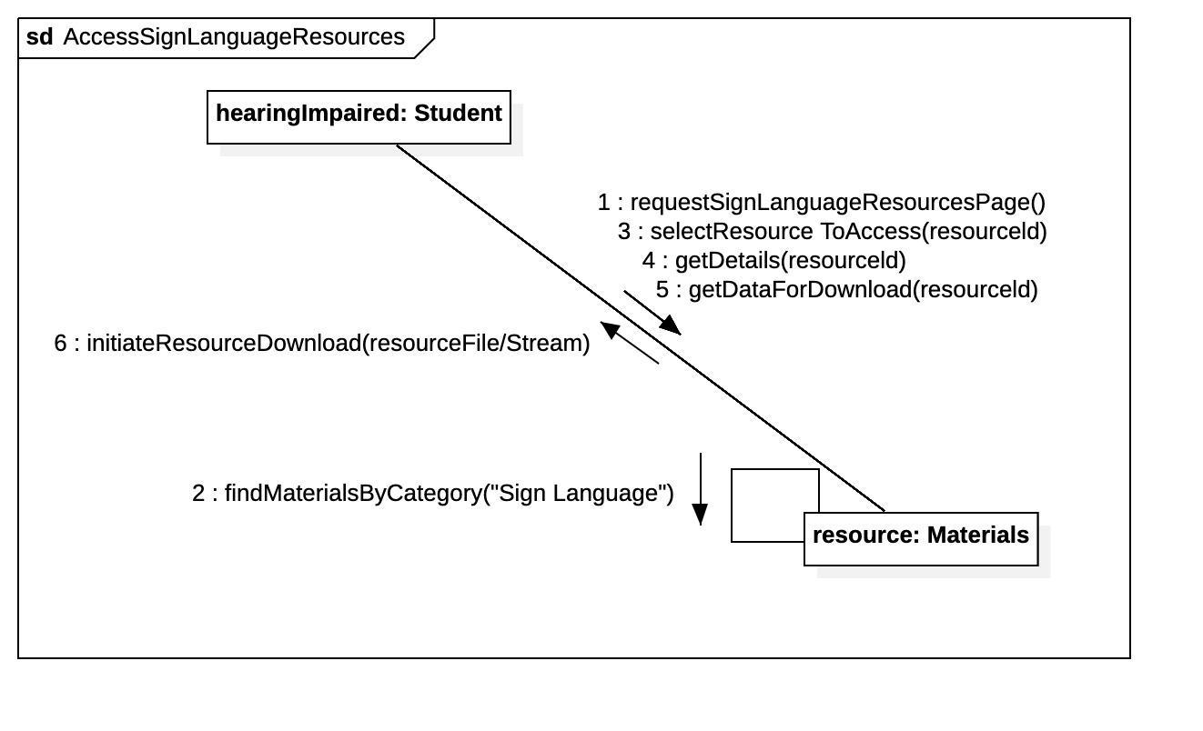

UC_13 - Marvi

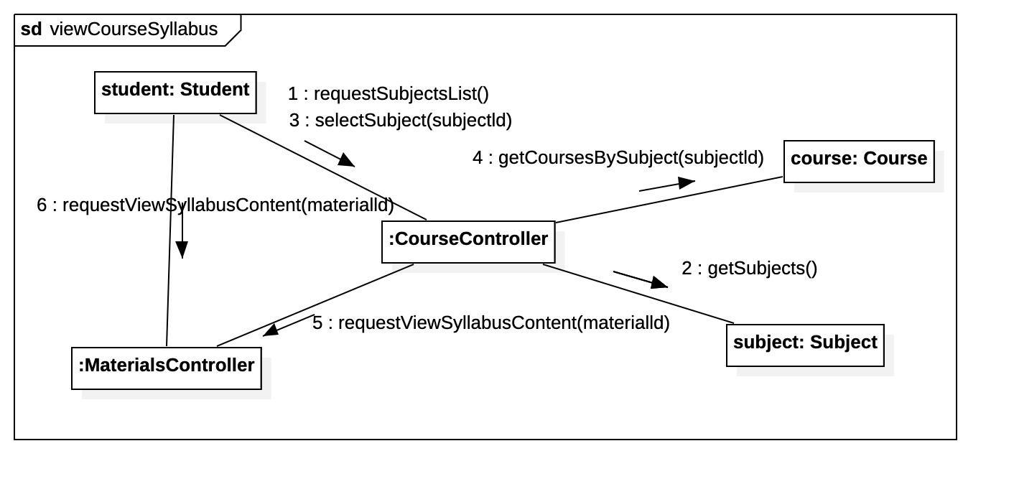

UC_14 - Halil

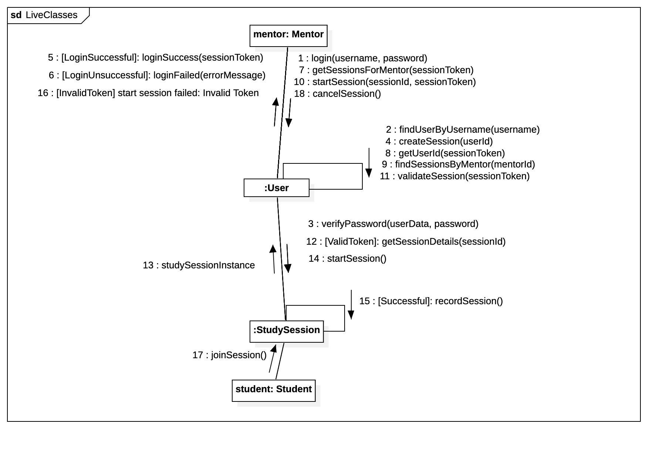

UC_15 - Halil

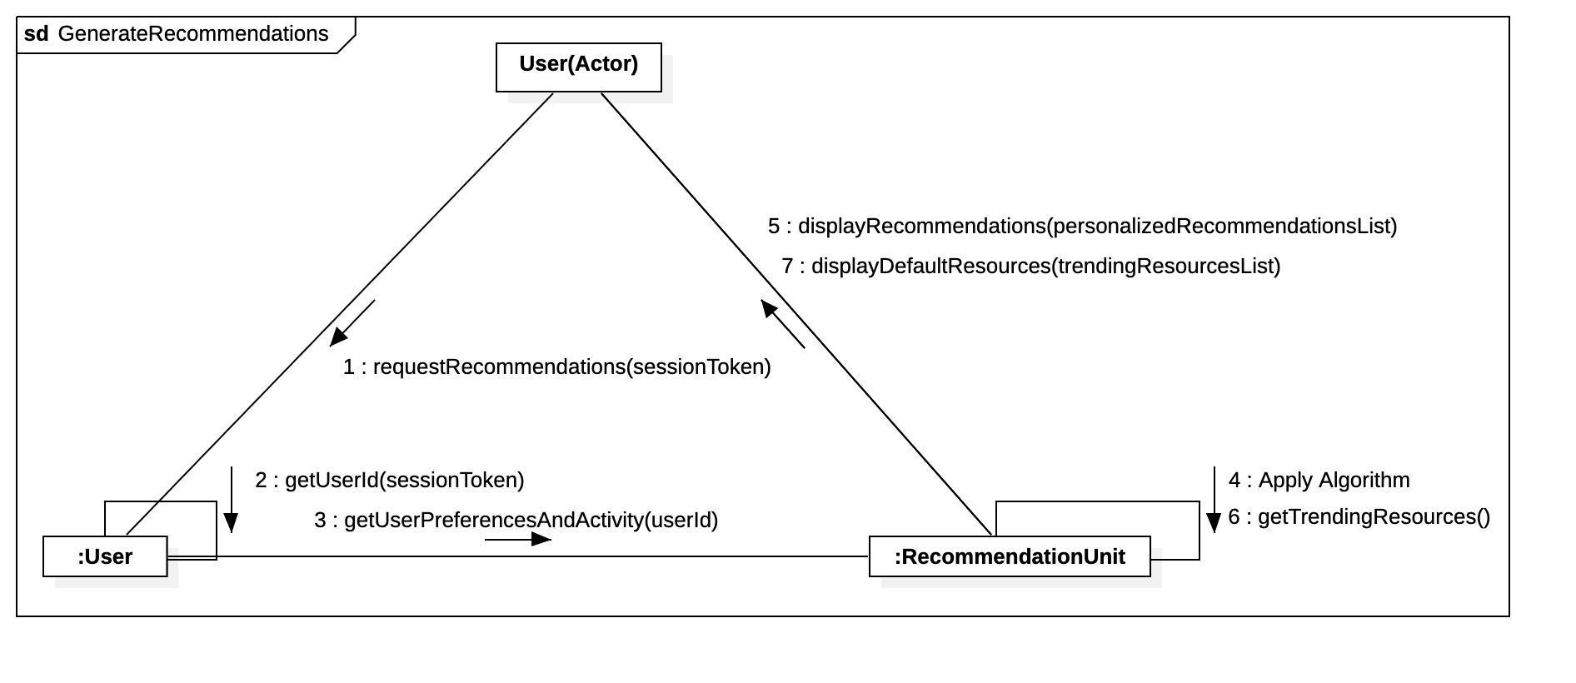

UC_16 - Halil

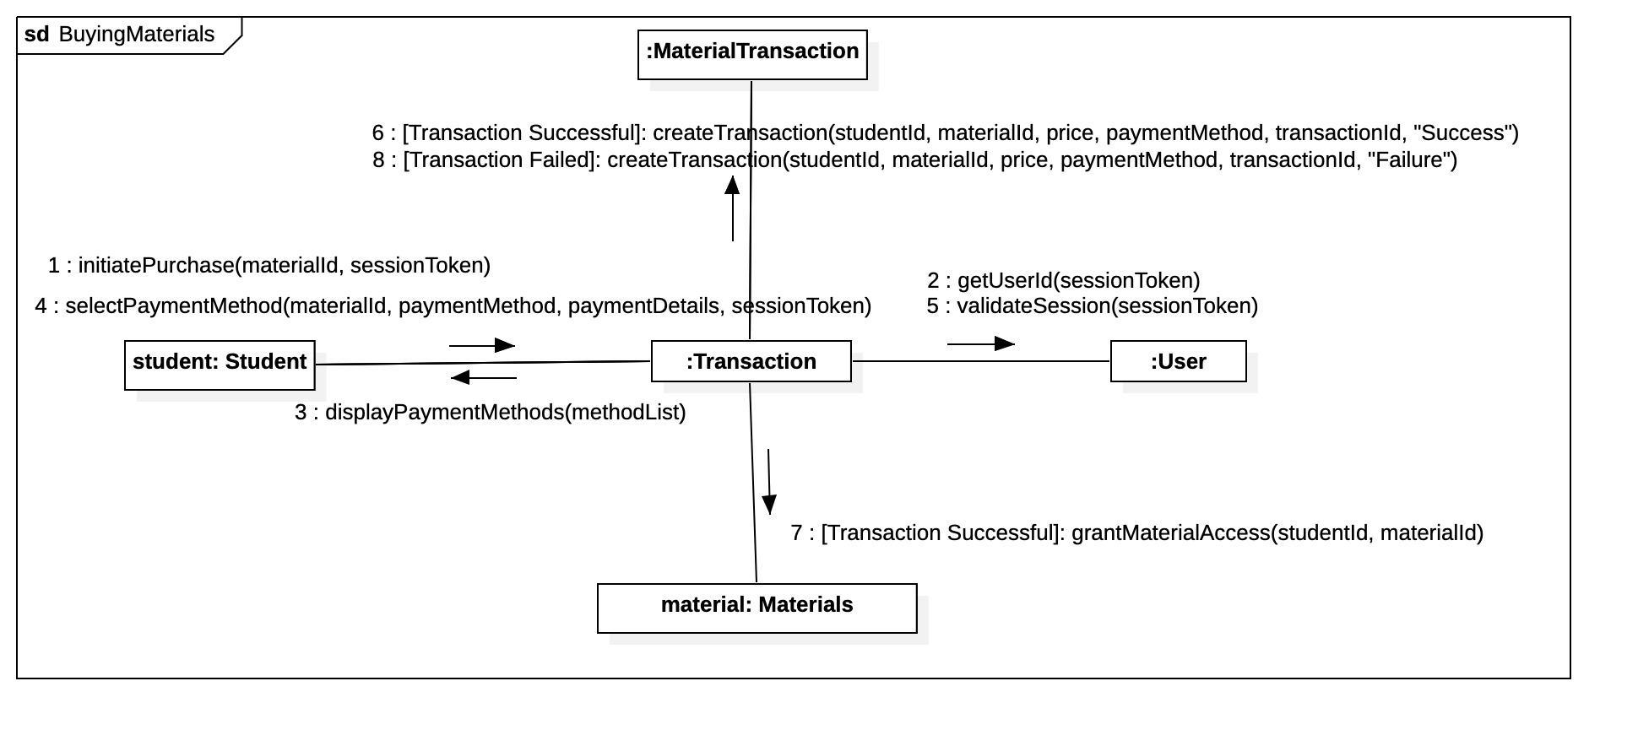

UC_17 - Halil

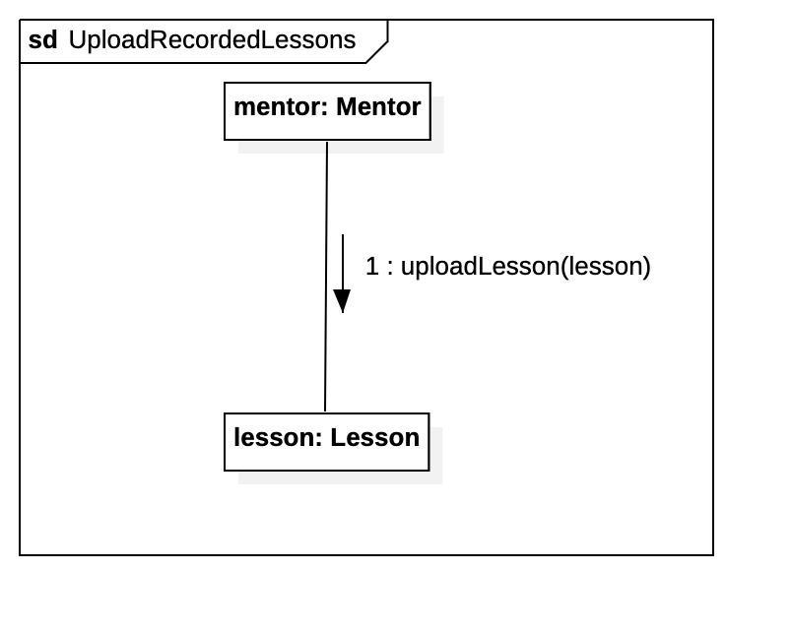

CD_18 - Dea

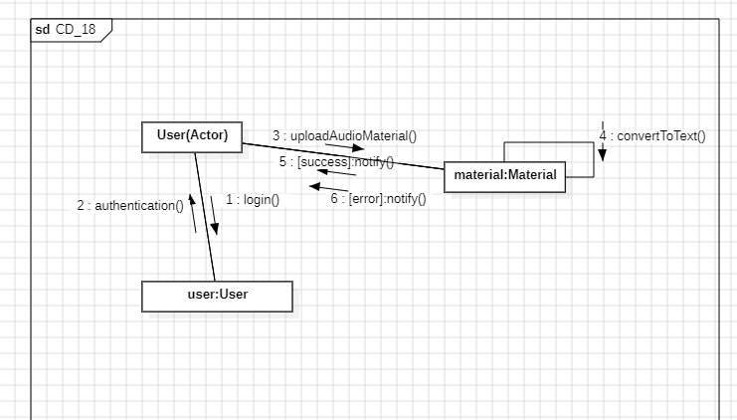

CD_19 - Dea

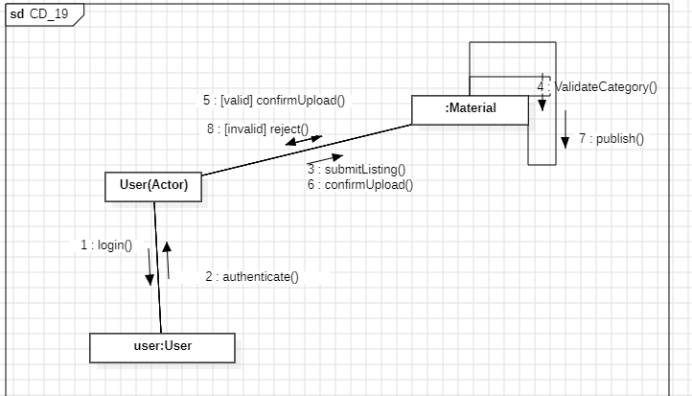

CD_20 - Dea

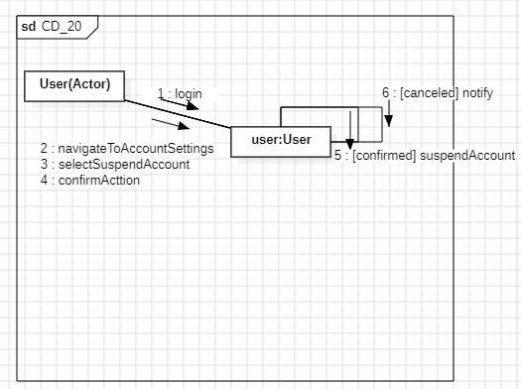

CD_21- Dea

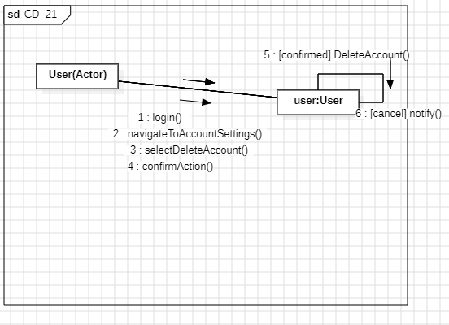

CD_22 - Dea

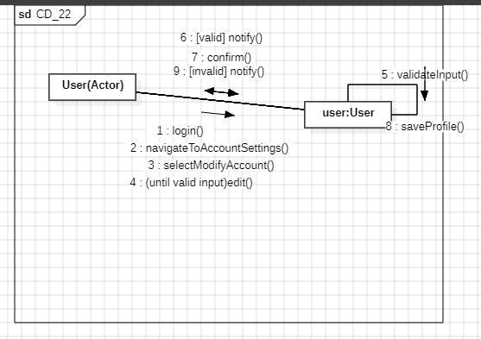

UC_23 - Ameraldo

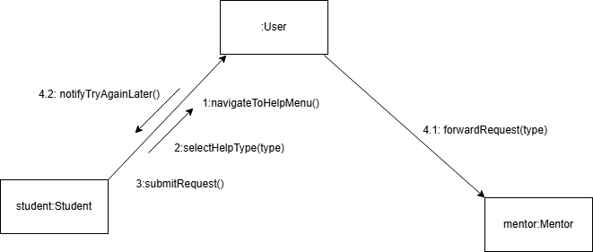

UC_24 – Ameraldo

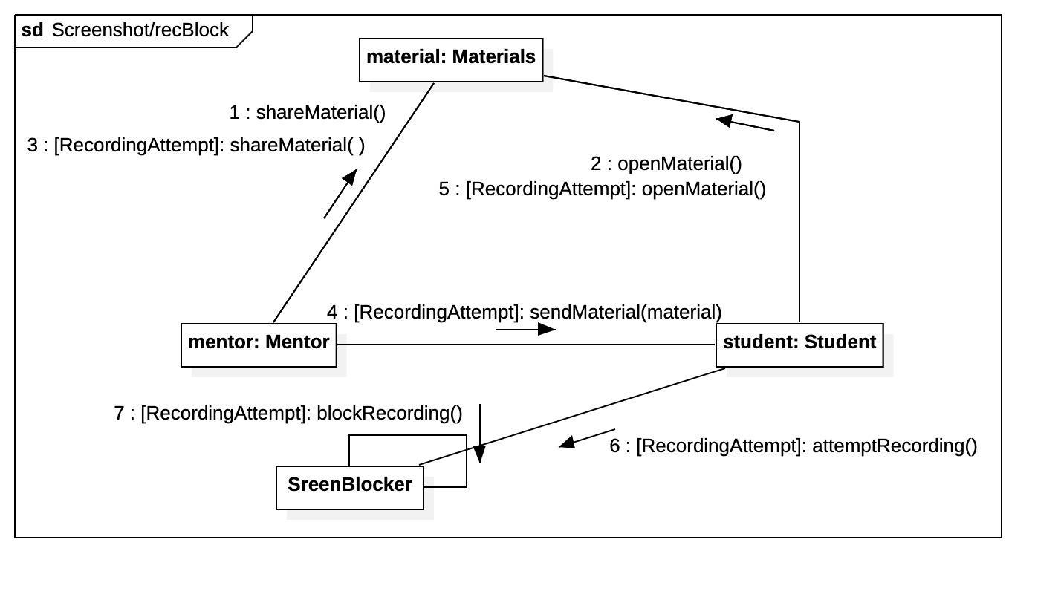

UC_25 – Ameraldo

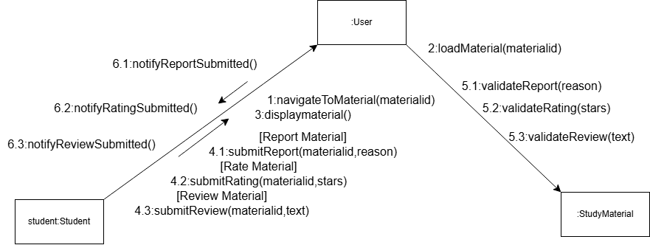

UC_26 - Ameraldo

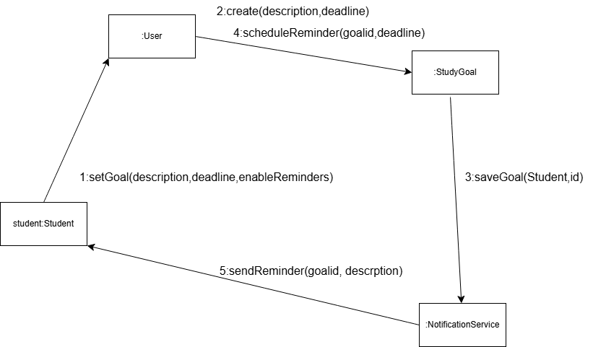

UC_27 - Ameraldo

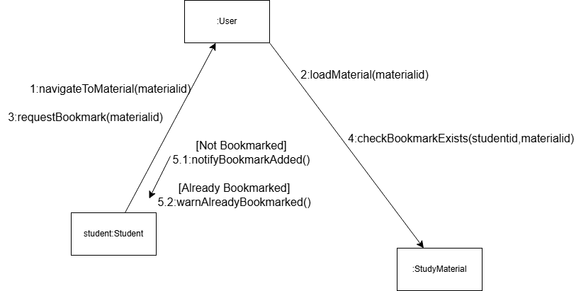

SD 28 - Daniela

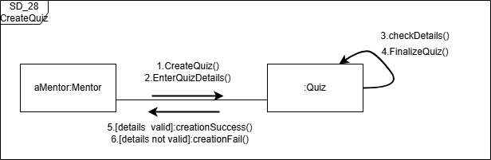

SD 29 - Daniela

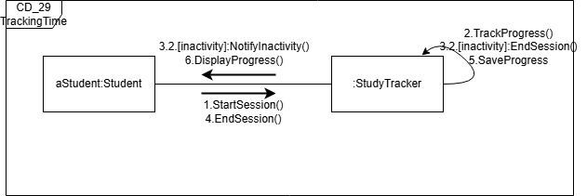

SD 30 - Daniela

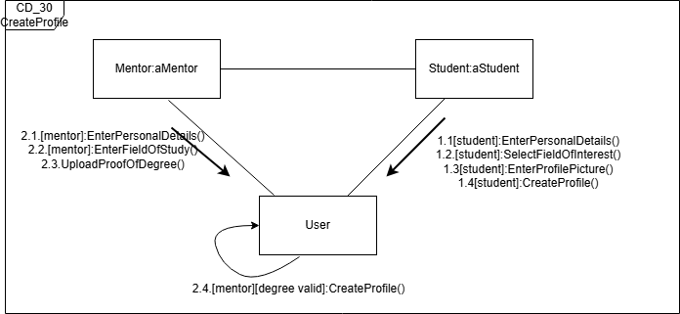

SD 31 - Daniela

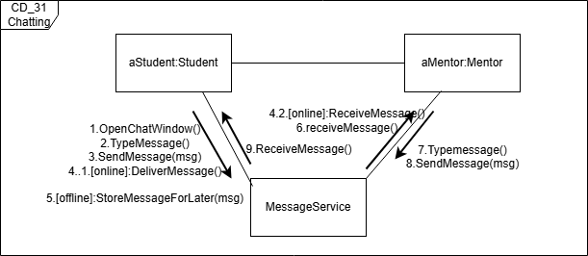

SD 32 – Daniela

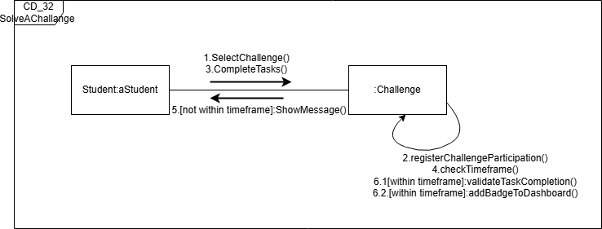

# Design patterns

## 6.1 Singleton Pattern

In the context of our Student Education Exchange System, the Singleton design pattern is applied to the RecommendationUnit class to ensure that there is only one centralized instance responsible for generating study material recommendations. Since recommendation logic should be consistent and shared across all students, creating multiple instances could lead to duplicated data, unnecessary computation, and inconsistent suggestions. By applying the Singleton pattern, we guarantee that all users access the same recommendation engine, maintaining global consistency, reducing memory overhead, and simplifying access. The class contains a private static instance variable and exposes a getInstance() method that initializes the object only once and returns the same instance every time.

**In RecommendationUnit class:**

1.getInstance(): RecommendationUnit

This is a static method that ensures the Singleton behavior. It checks whether an instance already exists; if not, it creates one and returns it. All students access the same instance through this method.

2.suggestRecommendation(student: Student): List<Material>  
This method takes a Student object as input and returns a list of study materials tailored to that student's academic level, field of study, or preferences. It encapsulates the recommendation logic and ensures that consistent recommendations are provided.

**In Student class:**

**getStudyRecommendations(): List<Material>**

1. 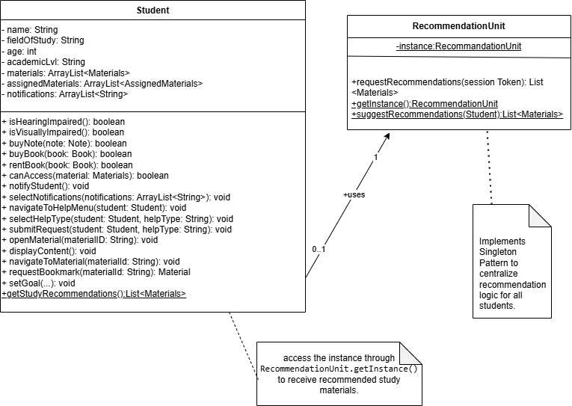This method is defined in the Student class to request recommendations. Internally, it calls RecommendationUnit.getInstance().suggestRecommendation(this) to retrieve materials relevant to the specific student. It abstracts the singleton call and keeps student-level code simple and readable. the specific student. It abstracts the singleton call and keeps student-level code

simple and re

## 6.2 Observer Pattern

The Observer pattern's presence is justified by its ability to decouple the objects that change state (Subjects like StudySession, Feedback, Transaction) from the objects that need to react to those changes (Observers like User, Student, Mentor). This ensures that observers are automatically notified and updated when a subject's state changes, promoting a flexible and extensible architecture for handling notifications and data synchronization,

**Registration**: When a User (or Student/Mentor) needs to be notified about changes in a StudySession,Transaction or Feedback, they call the addObserver() method on the respective StudySession, Transaction or Feedback object, passing themselves as the observer.

**State Change**: When the state of a StudySession (e.g., status changes) or Feedback (e.g., new feedback submitted) changes, the ConcreteSubject (e.g., StudySession or Feedback) calls its notifyObservers() method.

**Notification**: The notifyObservers() method iterates through its list of registered Observers and calls their update() method.

**Reaction**: Each Observer's update() method then retrieves the necessary information from the Observable (e.g., the new StudySession status or Feedback details) and reacts accordingly (e.g., updating a UI, sending a notification, logging an event).

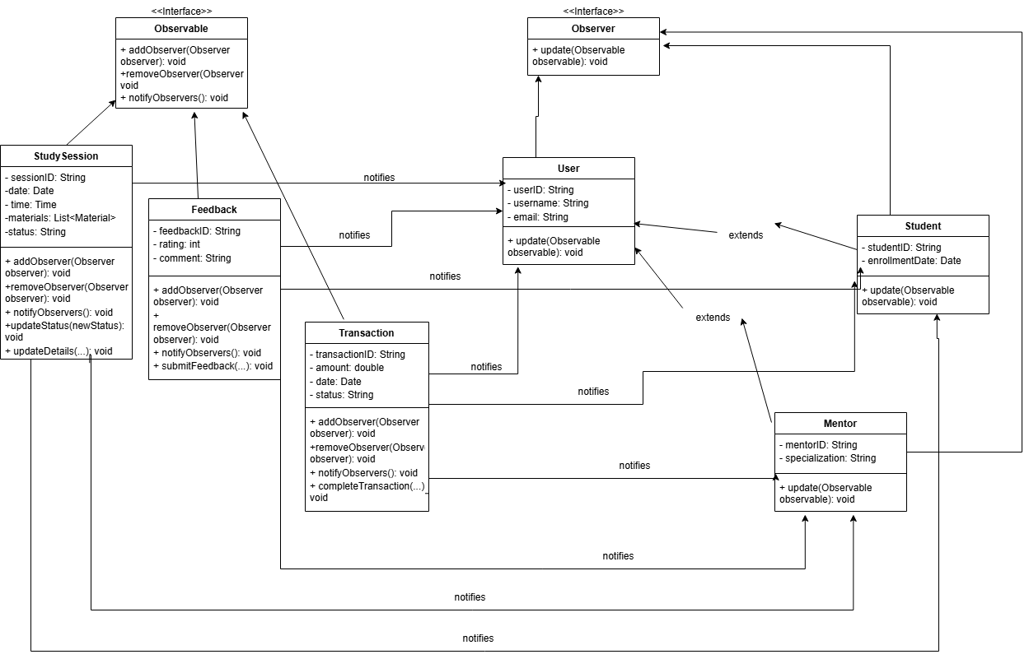

## 6.3 Facade Pattern

The Facade Design Pattern is used in the learning platform system to simplify access to its many subsystems. The **LearningPlatformFacade** provides a single, unified interface for interacting with components such as courses, study sessions, materials, memberships, and transactions. This prevents the client from needing to understand or manage the complexity of individual classes.

By introducing the facade, the system achieves loose coupling, meaning changes to internal components won't affect how external clients interact with the system. It also improves maintainability, as the facade centralizes key workflows, making it easier to implement logging, validation, or security checks. Additionally, the facade promotes reusability by coordinating common operations—like accessing materials or checking course eligibility—across multiple subsystems.

Overall, this pattern improves simplicity, supports future scalability, and ensures a consistent user experience across the learning platform.

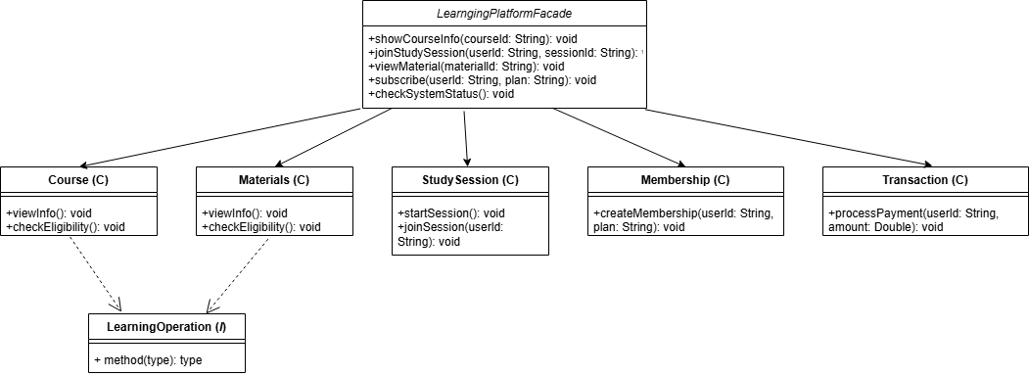

## 6.4 Factory Method Pattern

Implementing the Factory Method pattern for the TTSUnit class helps us manage the creation of different text-to-speech (TTS) engines in a clean and flexible way. Since the application might use various TTS services like Google TTS, Amazon TTS, or even a custom offline engine, we don’t want to hardcode these dependencies directly into the client classes. Instead, we define a common interface (TTSUnit) and use factories to decide which specific TTS implementation to create. This makes it easy to switch between providers or add new ones without modifying the existing logic in the rest of the application.

The factory method improves maintainability and supports the Open/Closed Principle, because the code is open to extension (we can add new TTS types) but closed to modification (we don’t need to change the main code). It also makes unit testing easier, because we can create a MockTTSUnit through a mock factory and test the system without depending on actual TTS APIs. Overall, the factory method fits well into our class diagram and project architecture by keeping responsibilities separate, reducing coupling, and making the system more adaptable for future needs.

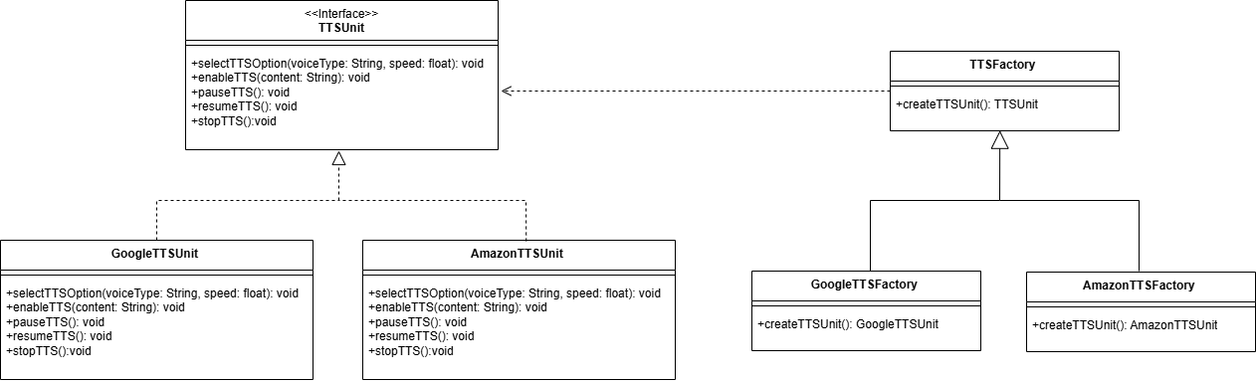

## 6.5 Decorator Pattern

In this system, the **Decorator Pattern** is an ideal choice for enhancing the Lesson class with optional, modular features such as subtitles, comments and analytics tracking — without modifying the core class structure. Since each lesson may require different combinations of these features based on user roles (e.g., students vs. mentors) or course types, the decorator pattern allows for dynamic and flexible behavior composition. It adheres to the **Open/Closed Principle**, enabling the system to extend lesson functionality without altering existing code. This approach also avoids deep inheritance hierarchies, promotes clean separation of concerns, and ensures future scalability as new lesson features can be added independently through additional decorators.

